**What is the Communications Industry?**

The communications industry referred to throughout your training relates to businesses within the telecommunications sector. According to the [North American Industry Classification System](https://www23.statcan.gc.ca/imdb/p3VD.pl?Function=getVD&TVD=118464&CVD=118466&CPV=517&CST=01012012&CLV=2&MLV=5), this sector consists of:

"...Establishments primarily engaged in providing telecommunications and/or video entertainment services over their own networks, or over networks operated by others. The establishments of this subsector are grouped into industries on the basis of the nature of services provided (fixed or mobile), the type of network used to deliver those services (wireline or wireless), and the business model they employ (facilities-based or resale)."

These businesses make large-scale communication possible through a range of products and services. They include wireless and cable infrastructure providers, telephone operators, internet service providers, satellite companies, cable companies, and equipment suppliers.

Telecommunications have come a long way since the invention of the telegraph way back in the 1830s. As the industry continues to evolve, regulation and barriers to entry have decreased, allowing companies who weren't traditionally regarded as telecommunications companies to join the sector, competing against big national and regional operators.

Rapid innovation in communications technologies creates challenges, with increased focus on internet and mobile services including video, text, and data rather than traditional voice calls on fixed-line networks. This was particularly evident during the COVID pandemic where people faced working from home for extended periods. The scope of products and services in the communications industry is expanding to include products, such as home security, software subscriptions, video streaming, and Internet of Things (IoT) support.

**Types of Communications Companies**

The communications industry consists of communications equipment providers and communication service providers (CSPs). Communications services include telephony, network services, internet services, television broadcasts, cable and satellite television services, and provision of managed services.

The communications industry includes three main sectors, and many large communications companies work in more than one sector. Click Start to find out more about the types of businesses within these three sectors.

**Types of Communications Companies**

1. **Communications Equipment Suppliers**

This is the largest sector.  It supplies the underlying hardware and software required on a network, including mobile phone handsets.

Examples of communications equipment suppliers include Cisco Systems, Huawei, and D-Link.

1. **Wireless Communications Providers**

This is the second largest sector in the communications industry. Wireless communications providers transmit analog and digital signals wirelessly using the radio spectrum to provide products such as WiFi, mobile phone services, messaging services, and GPRS (General Packet Radio Services).  
  
Wireless communications providers may own their own network infrastructure, lease a network, or combine leased and owned facilities.  
Examples of wireless communications providers include Verizon, T-Mobile, AT&T Mobility, and Dish Wireless.

1. **Communications Services Providers**

CSPs offer a mix of information and media services over networks, including wireless, satellite, cable, and landline services. Types of CSPs include telecommunications carriers, content and application service providers, satellite telecommunications operators, and cloud communications service providers.

Examples of CSPs include Deutsche Telekom AG, Vodafone Group, and Orange.

**Summary**

Most large telecommunications companies work across at least two sectors. Plus, many company sub-types operate in the industry, for example, providers of satellite services only and regional service providers who work in limited geographical areas.

The communications industry is like a patchwork quilt with all different colors and textures of business. We could elaborate all day, but let's move on to talk about market segmentation.

**Communications Market Segmentation**At the highest level, you can categorize CSPs by the types of products they provide: communications equipment, wireless communications services, or general communications services. CSPs further divide their markets into segments to provide the best, targeted products and services to their customers.  
  
Market segmentation splits consumers and business customers. Supplying to consumers is known as the B2C (business-to-consumer) market, whereas supplying to business customers is called the B2B (business-to-business) market.  
  
As shown in this diagram, you can further segment the B2B market by the nature of the CSP's customer's business. For example, is it a small to medium-sized business (known as a SME), a large enterprise, or a government/public customer? The diagram shows commonly used customer segments at the top, but how the segments are divided and applied varies from one CSP to another. It all depends on how the CSP categorizes their customers and the nature of the CSP's business.

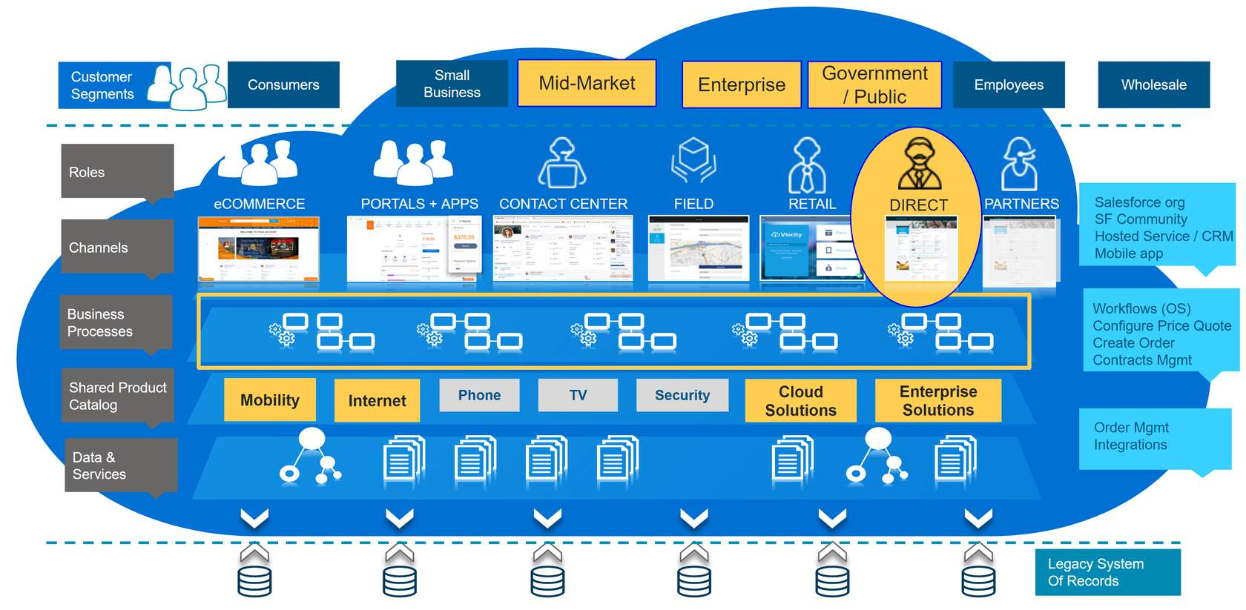

Although some products, services, and businesses are shared across all customer segments, most segments have their own products, services, and pricing. Some business processes are designed for particular segments. Therefore, most large CSPs cater for all segments in the market, with different roles and sales channels to support different customer segments.

For example, consumers and SMEs traditionally went to retail stores to buy products and services, as well as to get support. Now they use self-service portals and eCommerce sites. In contrast, large enterprises and government customers need deeper levels of information due to more complex service and regulatory requirements, so they generally have dedicated direct sales and support teams.

**Market Regulation**  
Telecommunications networks form a vital part of our everyday home and working lives, so these networks are critical to the infrastructure of most countries. For this reason, telecommunications networks tend to be regulated in terms of competition, innovation, consumer choice, and consumer pricing.

Some countries regulate markets heavily, and some maintain state-owned telecommunications companies. State-owned companies face little competition, with prices fixed by the government. However, the trend worldwide is towards deregulation and increased competition in the industry.

In the late part of the 20th century, many state-owned telecoms companies were privatized and large businesses broken up. Many large companies, such as British Telecommunications and AT&T were vertically integrated. This means they provided both telephony services and the hardware infrastructure required to deliver the services. This gave large companies an unfair advantage over potential competitors and led regulators to enforce a break up that separated service and infrastructure into different companies.

In more competitive markets, regulatory authorities often monitor the markets to ensure that consumers are getting a fair deal. Regulatory authorities include the Electronic Communications Framework/European Electronic Communications Code (Europe), the Federal Communications Commission (USA), and the Telecom Regulatory Authority of India.

**Impacts of Heavily Regulated Markets**

Heavily regulated markets generally have few competitors, if any. Barriers to entry are high, and often the same company owns and delivers infrastructure and services. Companies may be owned by the government. Examples of state-owned telecommunications companies include China Telecommunications Corporation, Telecom Egypt, and Televerket in Sweden.

The regulatory authority may set pricing so that customers have little choice in their purchasing decisions. However, benefits of heavily regulated markets include strict rules for service quality and use of resources, such as radio bandwidth. Regulatory authorities generally reinvest profits from more lucrative parts of the industry into infrastructure or supplying customers in areas that are more costly to service than others.

**Impacts of Deregulated/Competitive Markets**

In deregulated telecommunications markets, multiple suppliers tend to compete for a limited customer base. As discussed, regulatory authorities monitor most of these markets, which helps maintain fairness for suppliers and consumers. Authorities can also break up monopolies and encourage price competition, and governments can step in to ensure fair play.  
  
In a competitive market, consumer churn is common, with customers shopping for competitive rates and offers that suit their needs and lifestyles.  
  
Deregulated markets can be complex. For example, the infrastructure provider company is often separate from the service provider. This means when a service fails, it can be difficult to establish who’s responsible, and the consumer is left to sort it out.

**Core Functions of Communications Companies**

Have you ever wondered how CSPs make money? It’s pretty simple: CSPs create revenue by charging for products and services delivered to their customers. Well, maybe it's not that simple - because to ensure that customers buy their products and services, CSPs have to:

* Produce products and services that meet customer requirements and incorporate appropriate technologies.
* Make sure their customers are aware of the products and services suitable for their use.
* Deliver the products and services effectively and efficiently.

To complete these tasks, CSPs undertake some common processes and practices.

## Common Processes and Practices

Successful CSPs give the needs of their customers priority over the conventional function-focused aspects of the business. This includes providing products and pricing for specific market segments and tailoring products to meet customer requirements.

## Communicate with Customers

With so many different channels of communication available, good customer service tailors the communication methods to the preferences of their customers. Whether it's incoming or outgoing communications, CSPs should manage their customer contacts so they get what they need in a convenient way. This includes notifications about service activations and deactivations, and opportunities for customers to provide feedback.

## Provide Quotes and Place Orders for Products and Services

Different types of customers like to order products and services in various ways. For example, non-business customers often check product prices with many different businesses before they order a product. This could be through an online portal or with a sales agent. On the other hand, business customers tend to build up relationships with a small number of companies and spend time on the negotiation process before completing their purchase.

## Create and Deliver New Products and Services

Commercial and technical teams work together in companies to create innovative products and services.  They aim to launch products to market quickly for customers who may be interested.

## Answer Customer Queries

Customers may call the contact center to ask questions about their bill, order or service delivery, but this doesn't have to be the end of the conversation. With the right tools, service agents can use this time to build the customer relationship, and to make suggestions, including ways for the customer to save money by switching products or services.

## Manage Customer Moves and Changes of Service

All things change: people and businesses move premises and change the way they use their services. Service agents regularly talk with people who are moving to a different house and need their service changed. Service agents also work with business owners to upgrade products and services for their staff or to set up a new office network.

## Collect Payment and Give Payment Assistance

Service agents often talk with their customers about payments.  Sometimes this leads to conversations about non-payment, payment assistance, or collections.

## Deal with Service Issues and Callouts

Service outage notifications require two-way communication between a company and its customers. Customers can report a service outage and the company can communicate the outage to other customers through different channels.

Customers may also request callouts for both installations and ad-hoc issues.

## Communicate and Implement Offer and Price Changes

Products, services, and prices change from time to time. For example, products become obsolete, and charges may go up due to cost increases. Businesses should communicate these changes to customers and offer opportunities to discuss upgrades or additional products.

**Industry Data and Process Standards**  
Ok, so running a CSP is a complicated business!  Luckily lots of people in the industry are happy to share their lessons learned and best practices.

TM Forum is an alliance of over 850 global companies that work together to establish best practices for product modelling, process design, systems integration, and other everyday business challenges faced by the communications industry.  TM Forum offers training and certification programs and are leaders in establishing industry standards, including:

* eTOM - a business process framework
* SID - an information framework, including product models
* TAM - an application framework

TM Forum also provides numerous REST-based open APIs to support integration. The Resources section includes a link to the TM Forum website.

Useful Terminology

* Carrier

A company that sells telecommunications transmission services. Generally owns a transmission medium such as cable infrastructure, and rents, leases or sells portions for a fee.

* Hosted/Cloud Systems

Internet-based VoIP and data communications hosted off the customer's site in the cloud.

* Leased Line

A dedicated line, particularly useful for businesses that need to share a lot of data.

* Bandwidth

The rate data can be transmitted across a medium, which is measured in bits per second, such as Gb/s.

* Network Infrastructure

All the hardware and software used to manage data, voice, communications, and networks.

* Protocol

A set of rules and procedures for establishing and controlling transmission.

* LAN

Local Area Network: connects devices in a small area such as an office building.

* MAN

Metropolitan Area Network: connects devices within a metropolitan-sized area such as a large city or a small county.

* WAN

Wide Area Network: a series of networks connected over a wide geographical area. The internet is the world's biggest WAN!

* ADSL

Asymmetric Digital Subscriber Line: uses copper cabling from a local exchange to a cabinet near the building. Prioritizes downloading over uploading data.

* Broadband

A method of transmitting larger amounts of data than traditional telephony networks can support, such as voice and video data.

* VPN

Virtual Private Network: creates a closed, secure tunnel for data transmission between two or more networks.

* Analog

An older technology still in use today that uses a wave form generated from a sound or light source across a cable to transmit data.

* POTS

Plain Old Telephone Service (like they've had since the olden days, with a dial tone!)

* VoIP

Voice over Internet Protocol - technology that allows voice and media communication over the internet.

**Time for a Change**

Do any of these sound familiar?

* "My sales team spends more time managing manual back office and administrative tasks than they do selling."
* "The internal approvals process is creating a bottleneck in our B2B business."
* "Unresolved service issues are causing us to lose customers."
* "I can't see a full view of what's happened with a customer, so they sometimes have to repeat information to me that they've discussed with someone else at the company."
* "I waste time hunting around different places for product information."
* "Our systems are complicated, so I have to spend time switching from one to another to find the information I need and place orders."
* "We seem to have a lot more order fallout than our competitors due to invalid orders being placed by our customers and sales people."

Disjointed processes lead to confusion and customer dissatisfaction. Time to digitally transform your business!

## What is Digital Transformation?

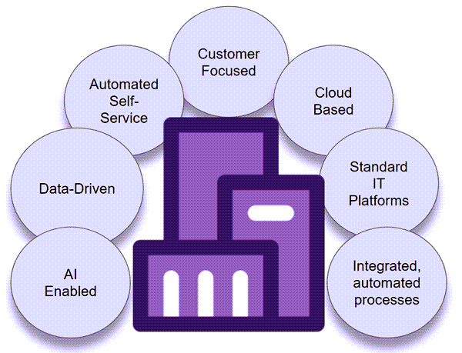

As you take your digital transformation journey, you change both the structure and culture of your company. You integrate digital technology into all aspects of the business, focusing on creating exceptional customer satisfaction and providing value.

Once you complete your digital transformation, your company is digitally native. This means you're more adept and agile in adapting to technology disruptions, time-to-market pressures, and customer expectations.

The image shows key features of a digitally native CSP.

**Who's Affected by Digital Transformation?**

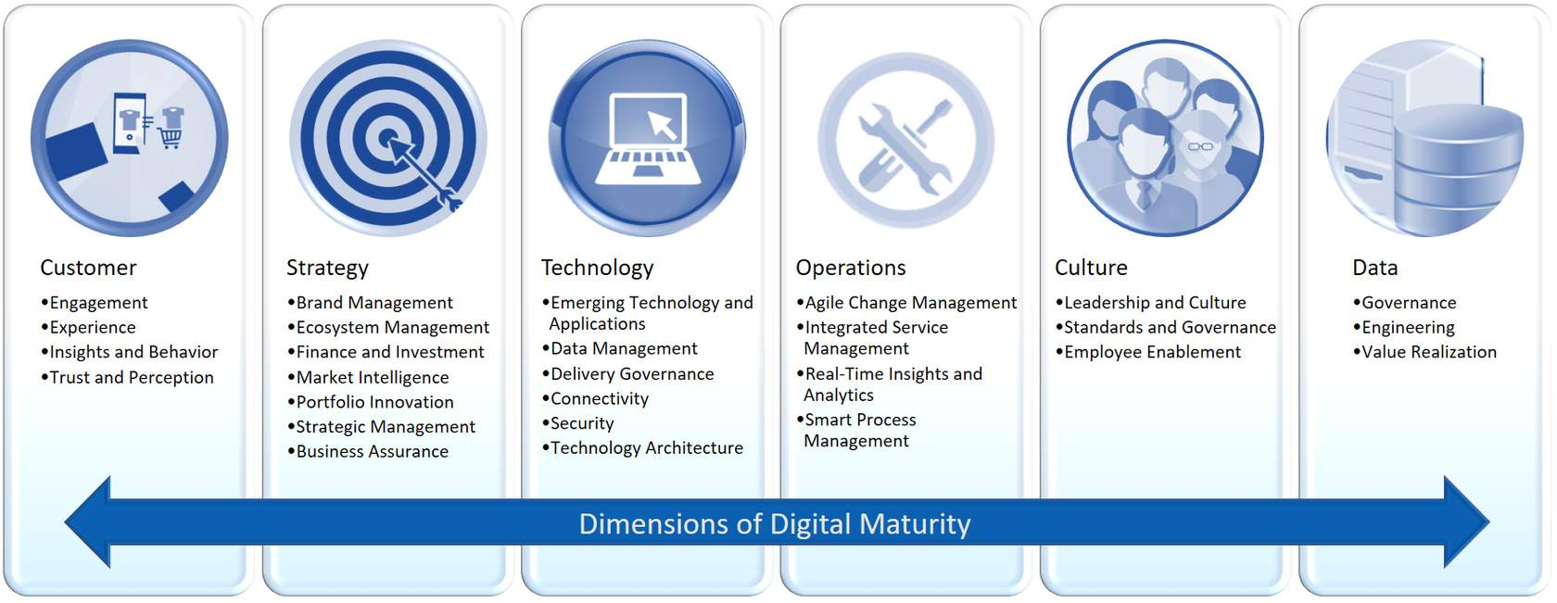

Digital transformation is an incremental process that takes place across all parts of the business.  Some parts are probably already further along the path than others. TM Forum's Digital Maturity Model shown here (graphic adapted from the TM Forum, [Digital Transformation and Maturity](https://www.tmforum.org/digital-transformation-maturity/)) is designed especially for CSPs working through digital transformation. The model outlines the steps to achieve digital maturity in terms of six dimensions:

* Customer experience
* Business strategy
* Technology
* Operations
* Corporate culture
* Data use

You can read more about the Digital Maturity Model using the web link provided in the Resources for this lesson.  You can also find links to benchmarking tools to help you assess where each of the above dimensions features in the maturity model for your company.

**What Slows the Transformation Process?**

These common roadblocks can slow down your digital transformation journey:

* Legacy systems that are difficult to change or scale to suit new business requirements
* Organizational data silos that hamper collaboration
* Poor communication between operational teams and business teams
* A risk-averse culture in the organization
* Lack of corporate vision for the path and goals of digital transformation
* Insufficient management capability or in-house talent to implement the transformation
* Underfunding of the project

Awareness of these roadblocks is important. Your Salesforce implementation team is experienced in dealing with these issues and will support you in reducing the risks they pose to the success of your transformation project.

**What Drives Success?**

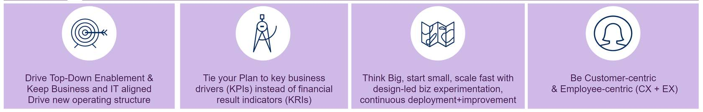

You can increase the success of your digital transformation with these key activities:

* focus on 100% customer success
* drive a lean governance model, and reinforce business outcomes to keep your transformation program on track
* use a platform ecosystem to set up an Agile operating model, with an emphasis on "clicks not code"
* build an executable business-outcome-driven transformation plan and validate and adapt this plan throughout the project
* take a whole-business approach: your transformation involves strategy, people, process, culture and technology

**Common Approaches to Digital Transformation**

You may choose to take one of three common approaches to transform your business:

* Digital customer experience (CX) transformation
* Evolutionary cloud business-support system (BSS) transformation
* Greenfield cloud BSS transformation

**Factors that Drive Digital Transformation**

Changes in the communications market, fast-paced innovation, and increased consumer demand for connectivity and new technologies are driving CSPs to change the way they work. Take a look at some of the key factors driving digital transformation in more detail.

**Deregulation**

The communications industry is showing an international trend towards deregulation, including the entrance of different verticals to the communications market. Deregulated communications markets are competitive with lower barriers to entry than their regulated counterparts. This means traditional CSPs are now competing with communications providers from other industries. Businesses in these industries often have an established customer base, such as the supermarket chain Tesco in the UK, which gives them a competitive advantage. Therefore, CSPs need to be more agile and innovative to compete successfully.

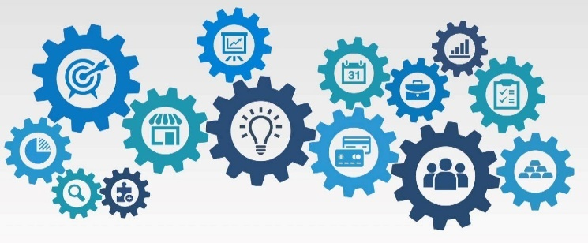

**Customer Expectations**

Customer expectations are a key driver for digital transformation in the communications industry. Customers expect reliability and personalization in the latest products and services. They now use multiple channels to gather information about the options available to them, to order, and to access customer service. Furthermore they expect to access information and services at any time and from any place they choose. Keeping up with this new type of always-connected consumer means providing a consistent and positive experience whenever and wherever they need it. A digital-first approach includes the use of analytics and omni-channel real-time interactivity to provide a fast, reliable, personalized service for customers.



**Rapidly Evolving Regulations and Technologies**

The pace of technological change in telecommunications and the associated legislation to deal with these changes have often been a challenge for the industry. Moreover, the pace of change is increasing. In particular, the COVID pandemic accelerated change and complexity, with greater demand for fast, safe, reliable networks, applications, hardware, and services to support people working and learning from home, and generally communicating with each other remotely. Further upheaval lies ahead with new technologies and increased adoption of cloud-based solutions for both domestic and commercial customers.

CSPs who were already well along the path to digital transformation before the pandemic have fared better than others.  The reason for this is that digitally advanced CSPs are better positioned to deal with rapid change.  This has driven other companies to look closer at ways to improve their processes through digitization.



**Product Complexity**

Fifty years ago, you could discuss cycle times for communications products in terms of years. Now, cycles can be just a few months. Conversely, the process of developing, building and deploying products has become increasingly complex, as have the many laws and regulations in place to protect suppliers and consumers.

Keeping employees up to date with rapid and complex changes and ensuring that CSPs operate within the confines of the law has become a time-consuming business. The time your company spends training sales people and customer service teams on new products and processes is time they’re not building customer relationships. Moreover, misinformed employees can make mistakes, which can be expensive in terms of lawsuits, employee churn, and loss of business through dissatisfied customers.

Successful digital transformation can help reduce the need for training, reduce complexity, and avoid costly mistakes by consolidating data and providing consistent, guided support for both customers and employees. This includes navigating common activities, such as gathering quotes, placing orders, dealing with customer queries, and product development and deployment. Digital transformation also helps businesses develop by providing insights into data collected across the business to better target growth areas.



Introducing the Communications Cloud Solution  
Communications Cloud extends Salesforce Customer 360 to provide a solution specifically for the communications industry that helps you deliver new, best-of-breed customer experiences while increasing operational efficiencies.

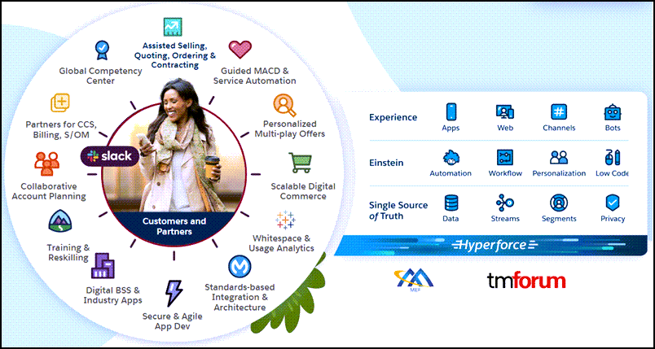

Communications Cloud gives you a deeper understanding of your customers so you can deliver personalized offers and experiences anywhere at any time, quickly launch converged service offers, capture accurate quotes and orders, author, negotiate and execute contracts, and orchestrate timely order fulfillment. With Communications Cloud, you can choose from hundreds of pre-built, best-practice industry processes, product models, and integrations to deploy transformation projects fast.

Salesforce Order Management, part of Communications Cloud, streamlines order fulfillment and orchestration. The solution provides pre-built integration to leading converged charging engines, such as MATRIXX Software and Nokia.

**Launch products faster**

Communications Cloud includes a shared product catalog especially designed for the communications industry. The underlying product model is compliant with TM-Forum standards and enables flexible integration with BSS and OSS systems. Use OmniStudio tools to extend the model with powerful, digital-process-automation technology called OmniScript. You also benefit from a library of pre-built business processes and productized integrations, which align with TM Forum Frameworx standards. All of these features facilitate faster product launch by enabling you to:

* Quickly define, launch, and update products, promotions, bundles and services from reusable product, service, and network resource components.
* Configure the workflows and policies spanning order configuration, decomposition, orchestration, and fulfillment.
* Flexibly manage commercial offer catalogs across product lines, business segments, partners, and geographies.

**Deliver personalized, efficient service**

Today's consumer:

* Wants you to know them and anticipate why they're calling.
* Wants a personalized experience.
* Does not want to wait.
* Does not want to repeat their details each time they contact you.
* Wants to drive the interaction in a way that feels right to them.

Communications Cloud includes Salesforce applications such as the CRM, AI, Analytics and Guided Selling tools, meaning you can:

* Instantly access customer profile information, including current services and  devices, preferences, relationships, billing, usage, and interaction histories.
* Automate the resolution of customer billing and service inquiries across assisted and unassisted channels using the Cloud's powerful, guided-service process engine.
* Gain insight into service effectiveness, and communicate and apply process changes in real-time.

**Capture and fulfill accurate orders**

Communications Cloud incorporates Industries CPQ and Industries Order Management, which streamline and improve your order process, including:

* Reducing quote-to-cash cycle time by guiding sales representatives through the configuration of complex quotes and multi-location, asset-based orders.
* Dynamically generating quoting and contractual documents, and then forwarding them electronically for customer review and approval.
* Orchestrating timely service fulfillment while providing customers, sales, and service teams with real-time visibility to order status.

**Onboard new sales and customer service employees quicker**

Guided selling and unified quote and order interfaces mean less time is required to onboard new sales and customer service employees.

**Manage your entire customer lifecycle**

Supporting the full customer lifecycle, Communications Cloud orchestrates quoting, order capture, billing, and service inquiry resolution across channels and devices. Users can view customer account relationships, active devices and services, billing, usage, and interaction histories for full awareness of the customer account and preferences.

**Challenges of Non-Centralized Data**  
If you work in the communications industry, you are probably already familiar with the challenges of non-centralized data. Data silos create unnecessary levels of complexity and can require substantial IT and product resources to manage. This complexity can cause problems, including:

* Data inconsistency
* Data redundancy
* Incompleteness of data
* Data inaccuracy
* Data unsuitability for business requirements

The Communications Cloud data model supports all the business and customer data needed to solve the underlying issues affecting data quality to ensure the perfect order for your customer.

**Data Model**  
The Communications Cloud data model supports all levels of product definitions, including offers, product specifications, services, and resource specifications.

The data model builds on these standard Salesforce objects:

|  |  |  |
| --- | --- | --- |
| Account  Contact  Product  Price Book  Contract | Opportunity  Quote  Order  Asset | Lead  Campaign  Activity (Event and Task) |

Here's an overview of the Communications Cloud data model.  It considers all the information required to create the perfect quote or order for your customer, whether they're a B2B customer or a B2C customer.

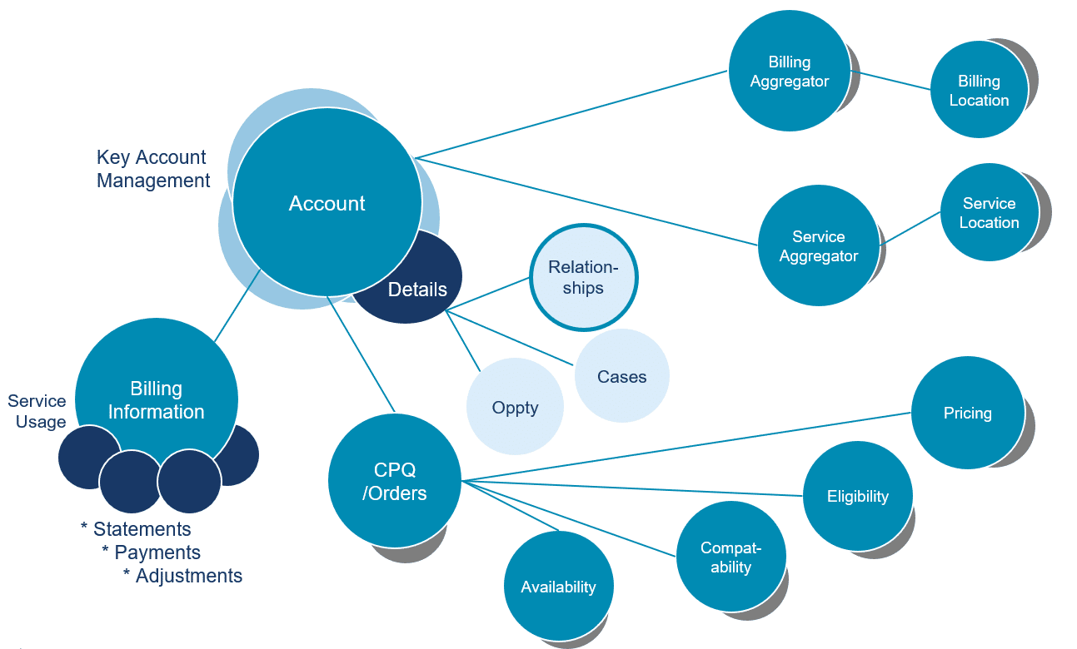

**The Communications Industry, Accounts and the Party Model**  
Salesforce Industries uses the standard Account object. An Account record is created for any company, person, or other party who is a customer, client, or prospect. However, in the communications industry, the Account object is used slightly differently from that of other industries. This is because account hierarchies are used heavily in the communications industry. For example, an account record could be created for a customer with child account records for service locations and a billing profile. The Account record holds details of its relationship to parties that are considered relevant to sales and service for the Account.

|  |  |
| --- | --- |
| 📝 | The Account object has been extended to address billing. Communications Cloud is not a billing system, but the Bill Line Item object is useful for holding billing information under certain circumstances. |

In multi-channel uses, the Account record separately asserts which parties are accounts to which of the internal or channel partner businesses. Therefore, if more than one internal business or channel partner considers the same party differently, for example, if it's a customer to one and a prospect to another, they each track this information separately in their own Account records. This is shown in the Party Model here.

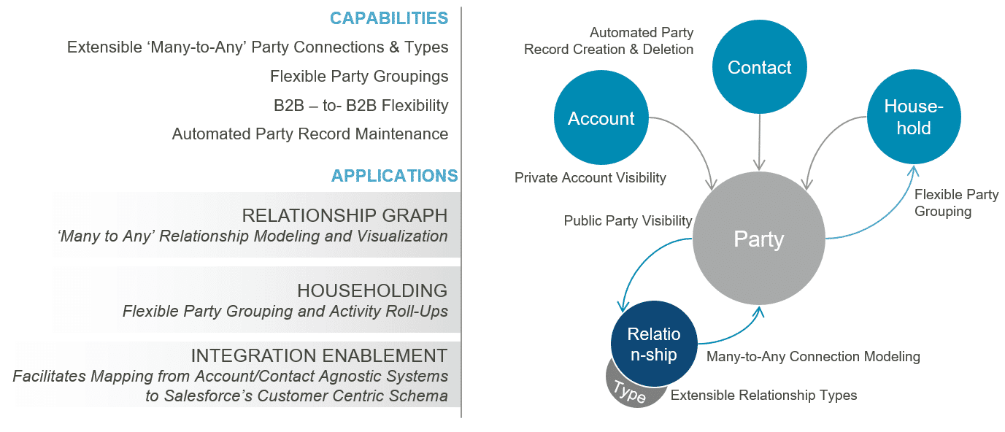

Here you can see the main data elements in the Salesforce Industries Party Model.  The party model is an important part of Communications Cloud.

* Any entity a Salesforce customer does business with is considered a party.
* All parties have a record in Party__c. People are stored in the Contact object, which is standard in Salesforce, while companies and other organizations are stored in the Company object.

**Assets in the Communications Account Structure**

In the communications industry model, Assets have three relationships:

* Owned by: points to a customer account that defines the owner of that asset.
* Billed to: tracks how the asset is billed.
* Serviced to: tracks who is using the asset (the service).

All three relationships can point to the same account, a billing account, or a service account.  Let's take a look at two examples:  a consumer or family account, and a business account.

1. consumer or family account

Here we see a collapsed **Account**record is a single consumer customer account that tracks the customer relationship, the billing profile, and the service user/location. In each of these accounts, the account contact relationship defines all the people authorized or represented as this consumer.

In this example, the customer account owns two assets.

* **Asset 1** is charged to the customer account and is used by the service user that's billed into that consumer account.
* **Asset 2** is owned by the consumer account but has an alternate billing account and alternate service account. The child billing account defines a second way that the customer is billed, and therefore this could be the way the customer is charged for this asset. The child service account could be a second user of the services and the asset points to that service account as well.

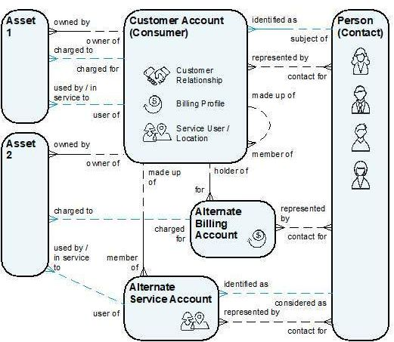

1. business account

Business accounts work slightly differently. For business accounts, it's common to have different records for the customer relationship, the billing profile,  and the service users. This is because there are always multiple users for a business and there are often different ways they want to be billed. Therefore, an asset typically has a different billing account and a different service account from the customer account, as shown here.

Imagine our customer is a hotel chain that's buying phone services for employees at their hotel properties and employees at their offices. The bill for the hotel employees is different from the bill for their office employees. In fact, there are different contacts on each billing account, because there are different accounting teams for the hotel employees and office employees.

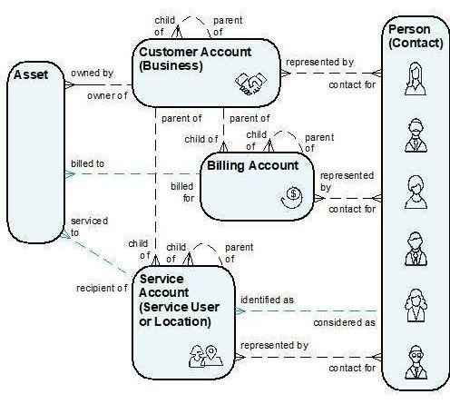

**What is ESM?**  
Consider a CSP selling products and services to a government department or a large enterprise. The quotes and orders can quickly become complicated due to large volumes of products and services provided to multiple locations  in different geographical regions.

This is where ESM steps in to support your sales team. ESM is part of Salesforce Communications Cloud. The solution extends common industry components, such as Industries CPQ, to deliver a unified, customizable selling experience for those working with large transactions for both fixed and mobile services. Sales teams use the bulk upload, bulk configuration, and group management features of ESM to quickly configure and estimate different solutions. This includes discounts for multi-location, multi-subscriber quotes and orders with minimal data entry. To make this happen, ESM includes communications-industry-specific guided processes, reference product models, proposal and contract templates, and order management orchestration plans to illustrate the end-to-end lifecycle, from proposal to agreement to fulfilment.

**Wow - So ESM Does Everything Out of the Box?**  
As much as we would like to say yes, the answer is "not quite everything". ESM is designed to create multi-location and multi-subscriber quotes and orders for enterprise customers, so the processes and data models relate specifically to those tasks. You can also customize ESM to suit your requirements. For example, you may want to customize your application to display costs, margins, or add actions, such as applying discounts. You can also use the components provided by ESM, such as APIs and Lightning Web Components(LWCs) to build solutions for your own customer self-service portals and applications.

**Who Uses Enterprise Sales Management (ESM)?**  
ESM is designed to support a specialist area of the communications market. As highlighted here in yellow, ESM specifically supports direct sales teams in CSPs with large enterprise and government/public customers. Medium-sized businesses that require single quotes for multiple locations or subscribers are also in the scope of the ESM quote and order process.

Customers in these sectors tend to have very large, complex orders and associated queries. They often have dedicated sales and support people in the company who can understand their intricate requirements. Therefore, as highlighted here, the roles most commonly associated with sales in the ESM domain are direct sales teams, which include roles such as sales executives and sales agents.

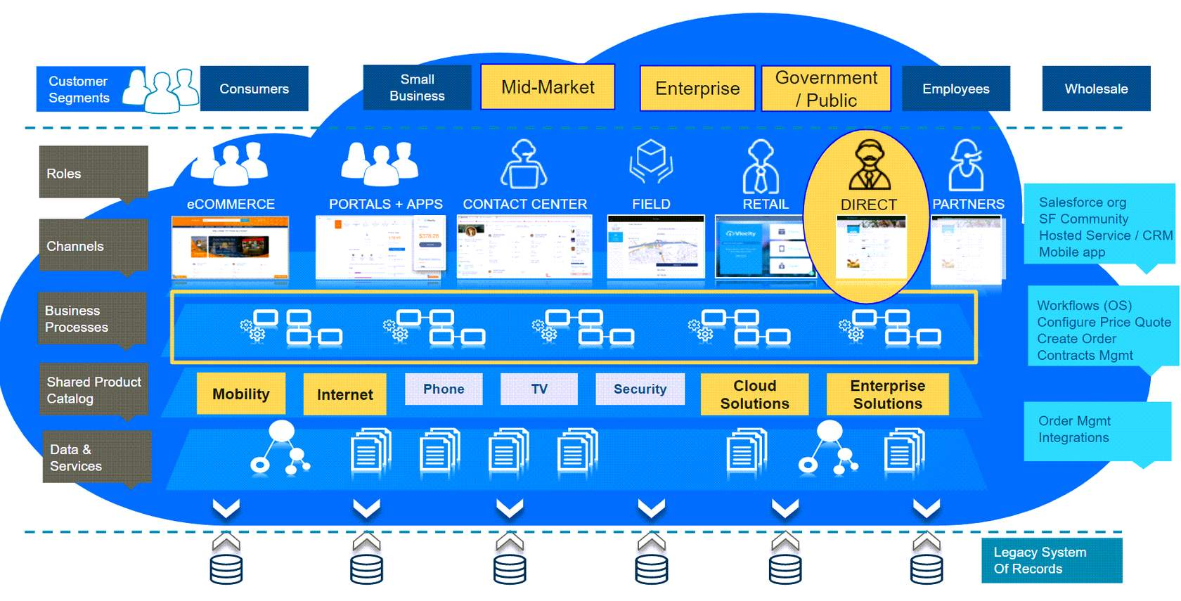

Every company is different, but most have several things in common. Let’s take a minute to think about your company. Who can benefit from ESM in your direct sales team? And how?

**Sales Executive/Account Executive**

Think about your sales executives. They often work with purchasing officers and technical leads from large companies or government departments. Sales executives build up solid working relationships with their clients over time and develop deep knowledge of their business processes and requirements. The goals of the sales executive are to:

* Create happy, long-term customers who want to continue the business relationship.
* Achieve selling targets and receive the big rewards associated with meeting those targets.
* Spend more time on building and maintaining customer relationships with large business and government customers and less time on forms and tools.

To help them achieve these goals, sales executive focus on their most important tasks, which are:

* Prepare for and conduct sales calls and meetings.
* Perform account planning and reviews.
* Define and present customer solutions, quotes, contracts, and proposals, which can be very large, detailed, and complex.

Sales executives may need to rework these deliverables several times over a long period before they’re approved and the order finally placed. However, they often face barriers to meeting their goals:

* Too many tools and an unpredictable pipeline make it hard to prioritize customers and tasks for  attention.
* The products and promotions on offer are complex, with a lack of guidance available.
* They feel they can’t trust the accuracy of the data available to them, and there’s no real-time data.

How can ESM help your sales executives?

ESM helps sales executives speed up the initial customer solution and quotation process, auto-generate proposals, and manage the complexity of multi-location, multi-subscriber quotes in a unified interface. With ESM, sales teams have all their tools and data in one place. This means it’s faster and easier to define customer solutions, create quotes, and manage the associated paperwork. They can use ESM to negotiate terms,  such as pricing, as well as incorporate previous contract agreements and make pricing adjustments. Sales executives no longer need to hunt around for real-time customer and product information, and the intelligent business rules built into the Shared Catalog support decision-making. Finally, as part of Communications Cloud, ESM makes it easier for your sales executives to monitor their accounts and stay on top of the sales process.

**Sales Agent**

Your sales agents deal with many different customers on a daily basis, especially those from small and medium-sized businesses. Therefore, their focus is less on building up a long-term working relationship and more about ensuring that customers receive a fast and efficient service. The goals of the sales agent are to:

* Create happy customers who want to continue the business relationship.
* Achieve selling targets and receive the rewards associated with that achievement.
* Quickly process customer queries in the most efficient and effective way possible.

To help them achieve these goals, sales agents focus on their most important tasks, which include:

* Follow prescribed processes to answer customer calls and queries as effectively and efficiently as possible.
* Maintain key knowledge on products and services the company offers.

Your sales agents may already be familiar with Industries CPQ, if they use it every day in their jobs. However, sometimes the medium and larger-sized businesses that contact them request a single quote for multiple subscribers or locations. Here it’s ESM to the rescue!

Unlike those of their sales executive colleagues, each of the quotes that sales agents create usually have only a few line items and generally deal with only a few quote members, such as subscribers or service locations. Customers often accept quotes and place orders quickly. ESM enables sales agents to provide quick, accurate quotes and orders for multiple locations or subscribers, and the built-in rules ensure best-fit and best-value deals for their customers. The ESM shared catalog provides the right product information when needed, including recommendations for customers.

**Sales Support**

Your sales support people provide data-entry support and specialized product or systems knowledge to other users. During the quotation process, sales support people may need to manually update proposals and contracts when quotes are amended. Once an order is approved, they may have to enter large-quote data into the order-management system.

The proposal and contract negotiation process can seem never-ending. Manual processes to update the documentation to match what has been agreed can take a lot of your sales support team's time. Plus, all the manual work is prone to errors. ESM integrates with Industries Contract Lifecycle Management (CLM) to ensure that throughout the negotiation process any changes to your quote, including pricing amendments, are automatically updated in the proposal. This saves sales support teams from having to re-key information into supporting documents each time something changes. This frees up time for other support activities and reduces manual input errors.

ESM integrates with Industries Order Management, minimizing the requirement for manual order data input by your Sales Support team. Product rules set up in the ESM shared catalog ensure that sales executives and sales agents create orders that are deliverable, include all the  information needed, and validated before submission. The long and short? This means reduced order-processing load for the sales support team, less order fallout, and less work to fix unfulfillable orders.

**Pricing Approver**

Your pricing approver receives requests to approve or reject product pricing, promotions, and discounts that have been created and configured by your sales executives and sales agents. This can get complicated! For example:

* Your customer may already have a pre-standing agreement, called a frame contract, which offers overarching discounts, or special pricing/discounts on specific products.
* There may also be discounts offered as part of a promotion, on a specific product range for a particular period of time, or for those in a particular region.
* Then, your sales person may choose to manually adjust the pricing for some products in the quote.

Wow - that's a lot to check! To help save your pricing approver from hours of trawling through approvals, ESM supports frame contract pricing and catalog-defined discounts. This reduces the need for manual pricing adjustments and approvals. You can also set up your approvals process so that automated rule-based pricing is automatically approved, reducing the volume of requests sent to the pricing approver.

The quoting interface of ESM shows any changes that are made to a standard price, so it’s easy for the pricing approver to see what’s changed and who changed it.

Although ESM doesn’t provide an out-of-the-box process flow for pricing approvals, it gives you the tools you need to configure and automate your pricing-approval process.

**Contract Approver**

A Contract Approver receives requests to approve or reject contracts.  
  
ESM gives you standardized templates that you can personalize with information from the quote. This reduces the time it takes for the contract approver to review contracts and the potential for errors.

Your company may choose to use ESM's integration with CLM to support monitoring of contracts throughout their lifecycles. CLM gives you tools to build custom contract-monitoring and approval processes to suit your business requirements.

**ESM Features**

ESM supports your business with ready-made features, including a user interface that you can extend and customize using a software development kit (SDK) and Lightning Web Components (LWCs). Here are some key features of the ESM application.

* Unified Selling Across Products
  + ESM brings together all the information your sales team needs to create and amend quotes in one place: a responsive UI you can customize to suit your business.
* Large Quote Management
  + ESM can handle thousands of line items across multiple product lines in a single quote.  Quote summaries contain groups of locations, subscribers, and line items.
* Pre-Defined Product Models
  + ESM holds product models for enterprise mobile, business internet and VPN products. Amend the product models to suit your business requirements.
* Guided Configuration
  + ESM includes customizable and extendable guided workflows for browsing and configuring offers and viewing quotes.
* Multiple Quoting Patterns
  + ESM supports multiple quoting patterns, including location-first quoting and product-first quoting.
* Location/ Subscriber/ Group Quotes
  + ESM enables you to add both subscribers and locations to a quote, and group them to speed the quotation process.
* Proposal Templates and Contracts
  + ESM includes sample templates to auto-generate proposals from your quotes and create contracts to support your formal documentation requirements.
* Pre-Defined Order Automation
  + Sample order creation, decomposition and orchestration plans are  included within the ESM application.
* Flexible Order Submission
  + Orders created from an enterprise quote may be submitted all at once as a large order, or as separate sub-orders at different times, depending on the needs of the customer.

ESM extends Industries CPQ, EPC and Industries OM to support your customer experience through the entire customer lifecycle, including quotes, contracts, orders, delivery, amendment, and renewals.

When you're in a sales conversation with your potential customer, ESM guides you through:

1. creating a quote
2. configuring details to provide a solution
3. pricing negotiation with discounting and manual pricing overrides
4. quote margin reviews
5. deal approval
6. contract finalization

**What's different about Enterprise Quotes?**  
Large businesses often request different products and services for different people (subscribers) or different places (locations) in a single quote. With ESM, you can add any subscribers or locations your customer wants to the quote. You can then group your subscribers or locations to simplify the quote process.  
  
Enterprise quotes are often large and complex, with thousands of line items. ESM helps you make sense of your quote, so you can view products sorted by location to be used, by subscriber, or by product, all in the same quote.

ESM performs well with high-volume quotes and orders and includes these capabilities:

* Bulk upload of subscribers or locations to apply to your quote
* Application of volume-based discounts across quotes and assets
* Bulk updates across line items
* Cloning of quotes and line items
* Group management of locations and subscribers

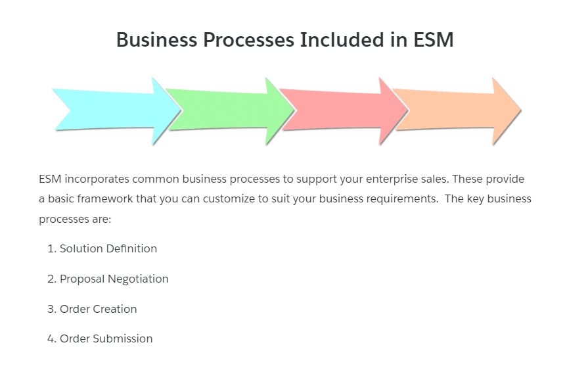

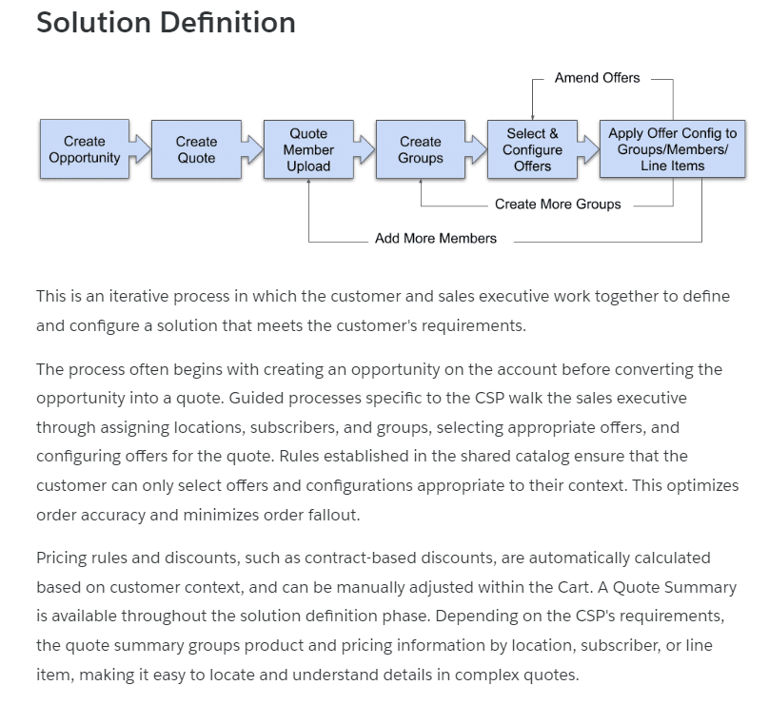

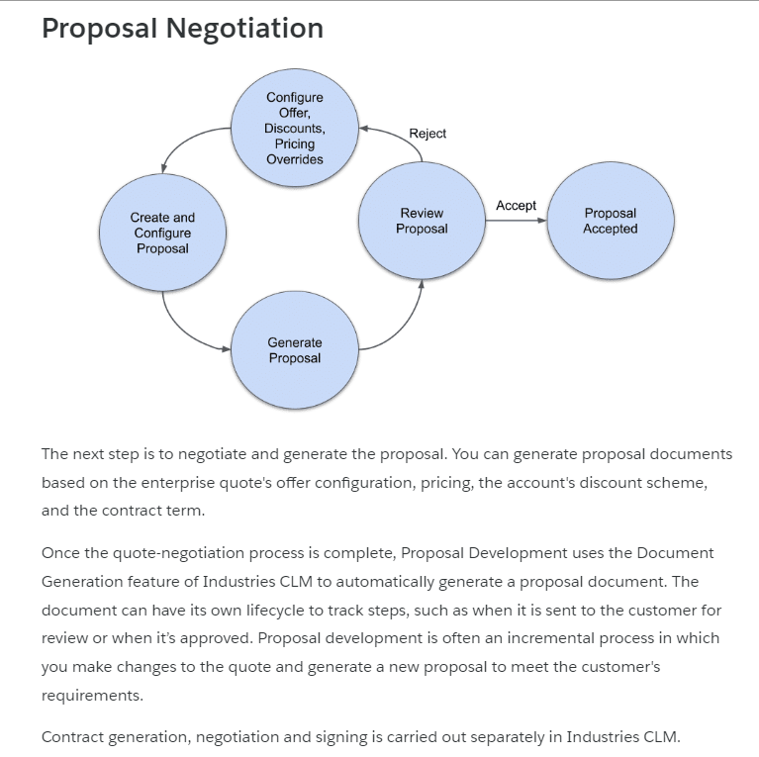

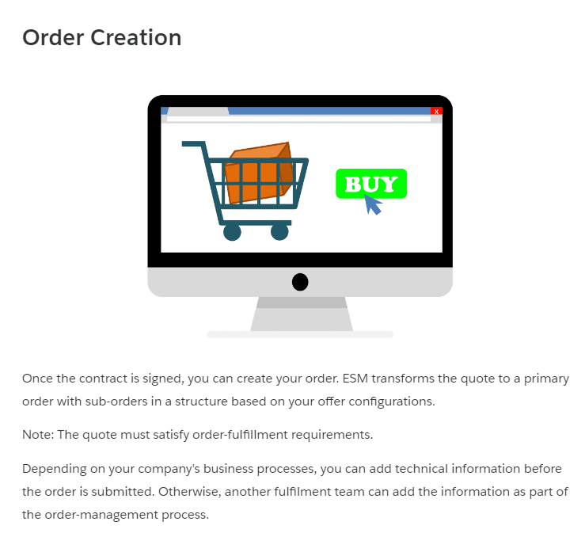

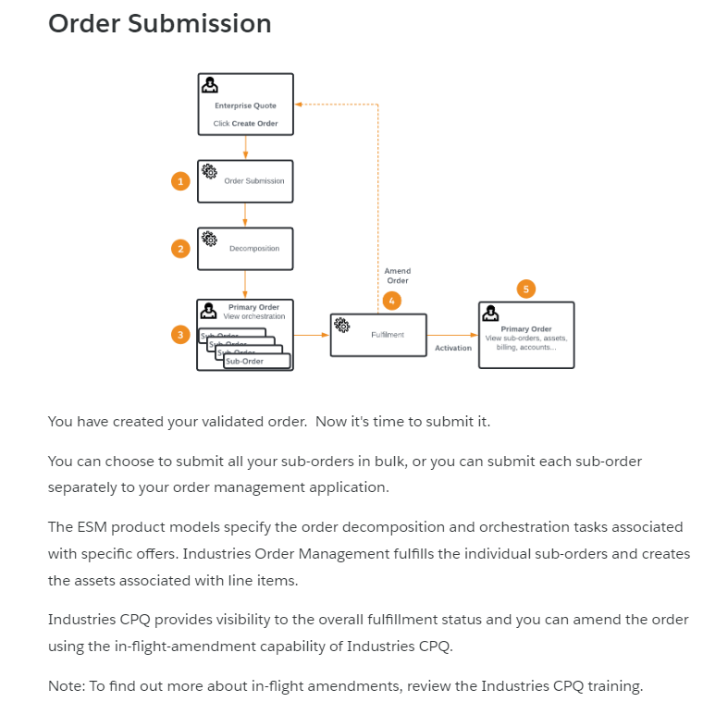

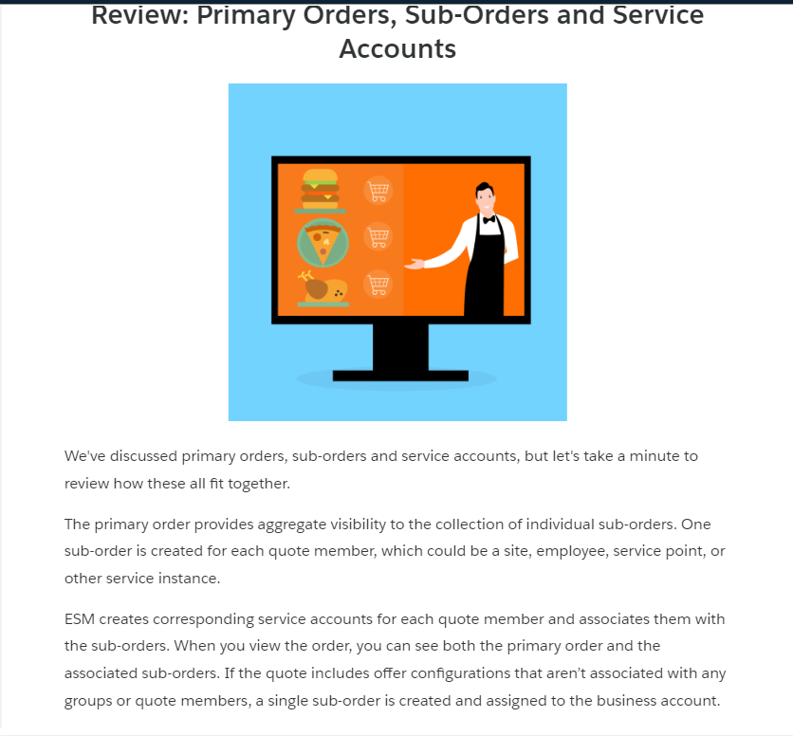

**ESM and Frame Agreements**  
ESM supports the price enforcement of frame agreements, also known as frame contracts, framework contracts or MSAs.

**What's a Frame Agreement?**  
A frame agreement is a type of contract. You can use Industries CLM to manage frame agreements. Use them to set up product-level, category-level, and account-level discounts to drive pricing of future sales. Frame agreements can also hold general, non-pricing terms, such as payment periods and warranty duration. Orders, quotes, and opportunities can refer to the frame agreement instead of price lists or price books during configuration and pricing. Use frame agreements to save time by avoiding the need for individual contracts for each new deal, because terms are pre-negotiated by the frame agreement.

**How Do I Create a Frame Agreement?**  
Your sales/account executive generally manages this process, negotiating a deal with the customer that results in the signing of a frame agreement. Frame agreements can be created directly from opportunities, quotes, or orders. The frame agreements move through the stages of the contract lifecycle, just like other contracts. You can generate documents from templates, create new versions, and so on. Once the frame agreement is approved and signed, its status becomes *Activated*, meaning the terms of the frame agreement are in effect. As shown here, quotes and orders created for customers then inherit the terms (both pricing and non-pricing) according to the frame agreement.

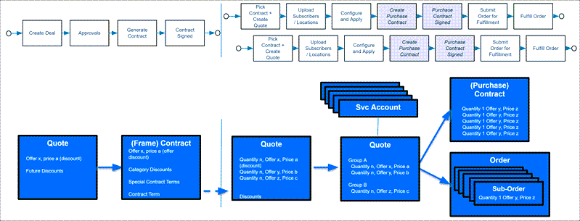

You can implement a Salesforce Industries open interface to price products using the frame agreement instead of standard price lists. You also can link a master frame agreement to one or more child contracts that are generated by child orders. What if your customer quote is eligible for two or more contracts with different negotiated prices for your customer? ESM is smart enough to choose the lowest price.

**The ESM Solution Map**

ESM and Industries CPQ are great partners and each solution gives you different capabilities. ESM works alongside Industries CPQ to provide  enterprise quote- and order-specific functions, such as multiple location orders. As part of the Communications Cloud platform, the ESM solution also complements the applications you already know, including the shared catalog (EPC), CLM and Industries Order Management (IOM). With Salesforce Sales Cloud, Service Cloud, and Lightning CRM, Communications Cloud forms part of Salesforce Customer 360.

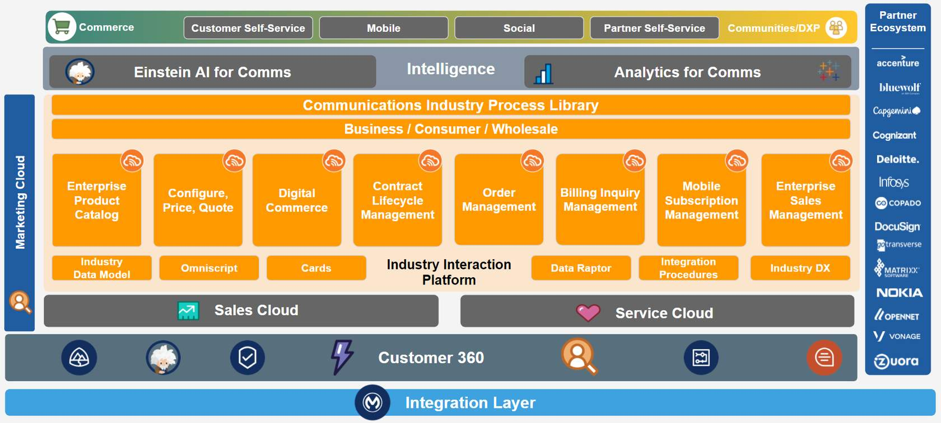

**The B2B Challenges of CSPs**

CSPs face common challenges in working with B2B customers. Do any of these challenges sound familiar to you?

* "It can be difficult to manage our relationships with our B2B customers, as they are so different. For example, smaller business customers often have shorter sales cycles, but large business customers have long sales cycles with highly customized offers and contracts."
* "B2B tends to have a wide, complex range of products that change frequently. This can make it difficult for the sales team to keep up to date with the products on offer and can also lead to errors in quotes and orders."
* "Legacy systems and different channels and routes to market create data silos, making it difficult to implement change or to gain insight through analytics."

Digital transformation can help solve these issues. Let's look at how ESM can help you on your digital transformation journey.

**Time to Transform**  
The purpose of ESM is to help you on your path to digital transformation, by navigating the complexity of selling to large enterprise and government/public customers. As shown in the diagram, ESM gives you end-to-end use cases that you can extend and configure to suit your own business requirements. You can use the interfaces, processes, product models, integrations, and analytics to help transform your business. Let's take a closer look at the components that help solve common industry challenges.

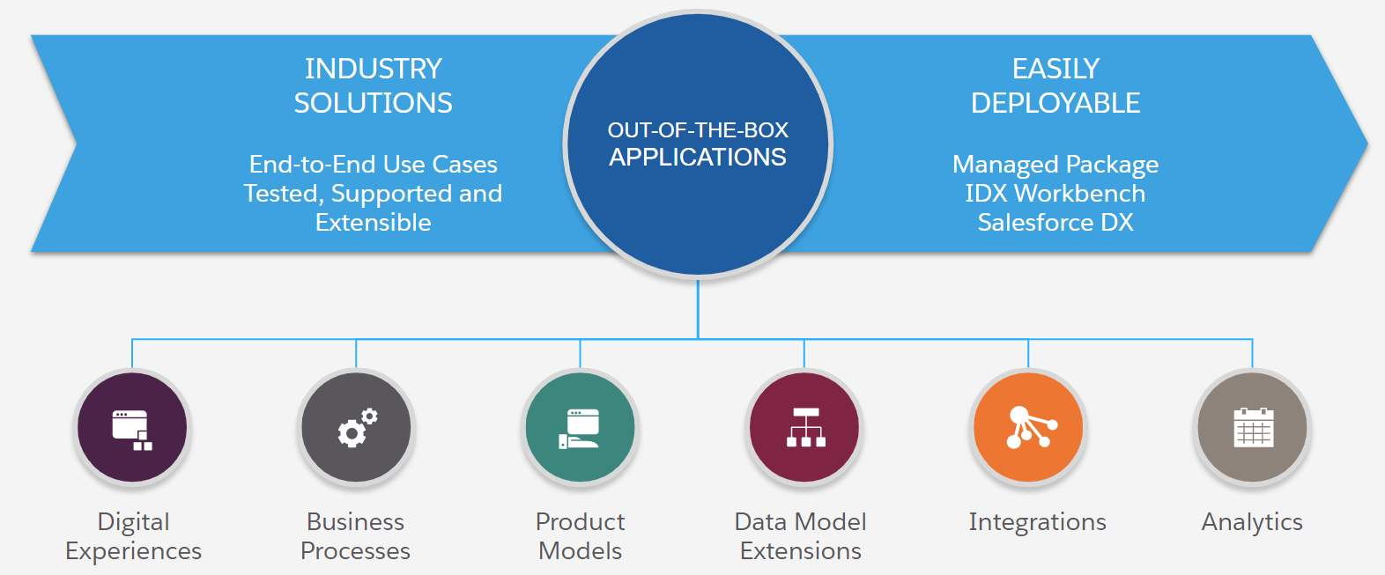

**Integration to Eliminate Data Silos**

ESM can reduce reliance on legacy system silos, streamlining and improving your selling and customer support experience. Prebuilt integrations, such as an integration with Google Maps help your sales team visualize and easily select office locations. Declarative tools, such as OmniScript and extendable Lightning Web Components lower integration costs and complexity, leading to fewer mistakes and a faster path to digital transformation.

**Structures to Support Complex Customer Relationships**

ESM incorporates digital experiences, models, processes and analytics to satisfy the complex customer relationships inherent in B2B sales and service. ESM is part of Communications Cloud, and builds on the functionality of Industries CPQ, which includes a shared catalog to build and bundle products. Use ESM to generate complex quotes across multiple sites, for multiple products that are governed by availability, eligibility, compatibility, and pricing rules set up in the shared catalog. As a result, opportunities, quotes, and orders are appropriately priced and validated at the time of submission, reducing customer issues, order fallout, and improving customer satisfaction.

ESM uses the promotions and discounts functionality of Industries CPQ to support your product and marketing managers in defining and executing complex promotions and discounts across channels. It allows personalization beyond offer pricing, through account, contract and segment specific discounts, and other high-value offers. Promotions and discounts are integrated into Industries CPQ for real-time visibility into terms, conditions, and pricing impacts. This way managers can react rapidly to offer the right promotions and discounts to the right recipients at the right time.

ESM includes business processes specifically designed to support large B2B customers, with creation and editing of quotes, and proposals provided out of the box to support those long sales processes mentioned earlier. Finally, ESM provides a seamless customer experience. You can automate and streamline order configuration, quoting, and approvals for sales and service agents, as well as for customers through Industries CPQ, CLM, and Sales Cloud.

**Contract Lifecycle Management to Support Long Sales Cycles**

ESM works with CLM to support the documentation aspects of the sales cycle, such as proposal and contract approval. CLM administrators can author and assemble contract clauses and templates into documents dynamically generated to meet the needs of sales users, resulting in lower cost and effort to do business.

Sales representatives know the assembled document is valid and structurally complete, reducing review and approval cycles. Pre-integration with the DocuSign electronic signature solution helps sales teams close deals faster.

Because CLM is integrated with Industries CPQ, contractual pricing is enforced throughout the life of the contract, and renewals are tracked and triggered, ensuring that renewal revenues are maximized.

**A Product Catalog to Manage Complex Products**

Alongside improving accuracy and productivity through the sales process, ESM works with the shared catalog - Enterprise Product Catalog (EPC), which provides a single point of truth for commercial product information. EPC empowers product managers to quickly create, launch, and update new products and service offerings from reusable product, service, and physical asset components. Product managers can use EPC to automate catalog-driven workflows, including order capture, complex order breakdown (decomposition), orchestration, and fulfillment. This makes CSPs more responsive to changing regulatory or market conditions. And the best bit? - ESM works with product rules built in EPC to show customers only those products and offers for which they’re eligible. This reduces quoting errors and order fallout, and takes a bit of pressure off your sales team!

**Integrated Order Management for Post-Sales Support**

ESM is integrated out of the box with Industries OM, which fulfills submitted orders by breaking them down into their component parts (decomposition), and then orchestrating them across relevant systems and parties.

At each point in the process ESM is updated, so your sales team can easily answer any order-related queries through the ESM interface.

Customers can make any changes to their order using Industries CPQ MACD (Move, Add, Change or Delete) capabilities.

**Implementation Decisions and Steps**

You may already have a tried-and-tested implementation methodology in your company, and that's fine - we can work with that! Salesforce Industries also has a preferred implementation approach, and you may find it’s just right for your business. Let’s think about some of the key decisions and tasks in each stage of the process. Then we’ll take a deeper dive into the decisions and their impacts.

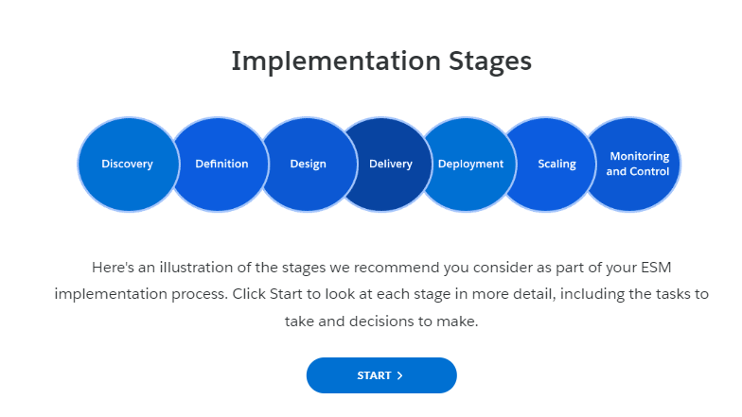

**Discovery**

By now you probably have a pretty good understanding of the benefits and capabilities of ESM. However, in the discovery stage of your ESM implementation, you should undertake a more detailed investigation into your current business processes and ESM capabilities to answer the these main questions:

* What is the business problem we're trying to solve?
* What does the solution look like?
* What are the technical pieces of the solution?
* What is the plan for implementing the solution?

Discovery generally takes around a month and includes documentation gathering, demonstrations, and workshops. Salesforce industry specialists hold the workshops with employees from your company, such as project sponsors, delivery owners, user champions, architect leads, and integration partners. The workshops are a way for you to collaborate with Salesforce experts on the best way to make your digital transformation a success. Once you’ve formulated answers to the main questions, you prepare a Discovery Findings document that describes the current problems, ideal solutions, and a recommended journey.

**Definition**

The definition stage helps everyone involved in the project to understand what’s involved in the implementation and sets the terms of engagement for the project.

You learned lots about solution definition in the module Define the ESM Solution. But wait, there's more. When you prepare for your implementation, you delve further into solution specifics and determine the finer details of your implementation. This includes project specifics like estimating costs and preparing the implementation team.

Definition involves determining the fine details of the implementation, including outlining a project plan, estimating costs, and preparing the implementation team. Examples of decisions you make during the definition stage include:

* What’s the roadmap for the implementation?
* How do we manage the project?
* What processes should we put in place to manage any changes to the plan?
* Who from the company should be involved, and when?
* How do we communicate, both in the team and across the company?
* How do we upskill those in the company who’ll use ESM?

**Design**

The design stage focuses on an holistic approach to the project and aligns the team on  who’s doing what and when. This includes ensuring that the teams are ready to work together, and defining the roles, responsibilities, and standards each team member needs to meet. In this stage, you also design the project outputs and prepare the plans to deliver those outputs. Decisions you need to make during the design stage include:

* What are the finer details of the data model and processes in our solution?
* Do we have enough detail in our design plans to start work on developing the solution? Are there any gaps?
* How do we test our solution?
* When do we release each part of the solution?
* How do we measure the successful implementation of each part of the solution?
* Who’s responsible for each part of the plan?
* How do we approach data migration and backups?
* What development tools do we use?
* Is there a code repository set up? If not, which one do we use?

**Delivery**

This stage is when you find out how good your discovery, definition, and design stages were!

Delivery is an iterative process, where you build your agreed solution using best practices and the practices and ceremonies of your chosen methodology. Throughout the delivery stage, you test your solution to ensure it’s usable and high quality.

You’ll likely find things to adapt along the way. For this reason, ensure that a change-management process is established to deal with changes efficiently.

Consider developing training materials during the delivery phase to ensure your end users can quickly use their new systems.

Decisions during the delivery phase include:

What work can we allocate for the current sprint?

* Are any obstacles stopping or delaying us from meeting our planned deadlines? If so, how can we overcome these obstacles?
* Is the project running on time and in budget?
* What have we learned so far that can inform future decisions?
* How should we document the solution for training purposes?
* Is the training plan in place and ready for implementation?

**Deployment**

Now that you've developed the solution, it's time to deploy it. This involves implementing what was agreed, migrating data, preparing and delivering training, and completing formal acceptance of the application as being "live".

Follow-up on the deployment is important to ensure that the new system is fully adopted and provides business benefits.

No doubt you should document lessons learned throughout the design, delivery, and deployment process to help ensure they’re incorporated into future project stages.

During this stage, you need to make these decisions:

* Which feedback from users should be incorporated into a solution improvement program?
* Is the project handover fully completed to the satisfaction of all involved?

## Scaling

Depending on the nature of the project, at this point, you may want to scale the project. This may involve, for example, increasing the scope to cover a wider range of products or another enterprise market segment.

Often this means repeating discovery and subsequent stages - but this depends on your planning and deployment teams.

## Monitoring and Control

This stage is a vital part of ensuring your implementation remains on track and successful. You should apply monitoring and control throughout the project. It involves tracking, reviewing, and orchestrating the progress and performance of your ESM implementation.

Examples of monitoring and control activities include expense monitoring and financial tracking, project forecasting, and collection of end user feedback. This stage also involves success monitoring, such as reviewing business benefits achieved by the implementation.

It may be that over time the solution needs to change to meet new requirements. In this case, carry out the implementation process to discover, define, design, deliver, and deploy the changes as efficiently and effectively as possible. Always take into account the lessons learned from the previous implementation

**Summary**

You’ve learned about our suggested implementation steps for your ESM project. You might have a slightly different approach, and that's fine - we can do it your way!

To recap, the key stages follow:

1. **Discovery**- Identify what's going wrong and how ESM can fix it.
2. **Definition**- Set the terms of the engagement.
3. **Design**- Detail the work to be done in the project, and who will do it.
4. **Delivery**- Create the solution.
5. **Deployment and Scaling** - When the solution goes live and, in terms of scaling, where its scope extends. For example, does the solution include new products, geographical regions, or markets?
6. **Monitoring and Control** - Track and review progress during each stage, including after handover, once the implementation is complete.

If you have more questions about your implementation, talk to your Salesforce implementation team.

**Getting it Right, from the Beginning**

Project success hinges on getting the early stages of the implementation right. Establish the project goals, objectives, benefits, and commitment to success, and communicate these principles to everyone right from the start. Consider these example objectives for your ESM implementation:

* ESM provides a single source of truth, including what we know about our enterprise customers, the products and services we sell to our enterprise customers, and the employee deal compensation scheme. This has made our sales process faster and more accurate and has reduced the time spent dealing with quote/order troubleshooting.
* Our direct sales teams now work within a single interface designed to guide them and help perform all their key sales functions. This means they can to spend more time on customer sales and less time on upskilling, problem-solving, and troubleshooting.
* We use the real-time reporting and analytics provided with ESM to support and refine our enterprise sales activities. This way, we can decrease customer service costs, improve customer satisfaction, and optimize our financial performance.

Ensure that your objectives/goals are specific and measurable, so that you can demonstrate you’ve achieved them. To give you some ideas, look at these metrics from the Salesforce Customer Success metrics database.

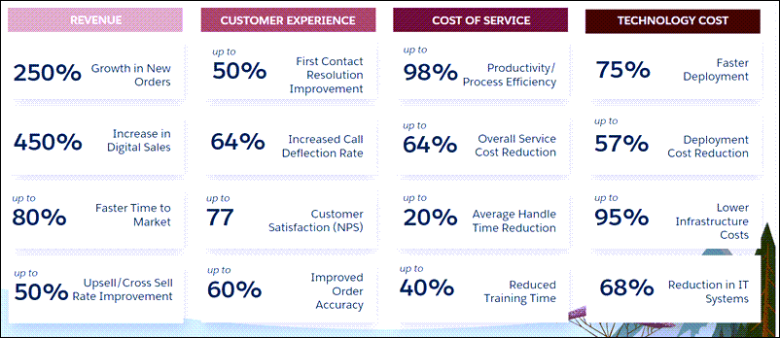

**Let Everyone Know**  
Poor buy-in from those who will use ESM leads to poor implementation success. Therefore, start thinking now about who you want to involve in your company and how you intend to keep everyone up to date with progress. Here's an example to get you thinking about who to involve and when you should meet.

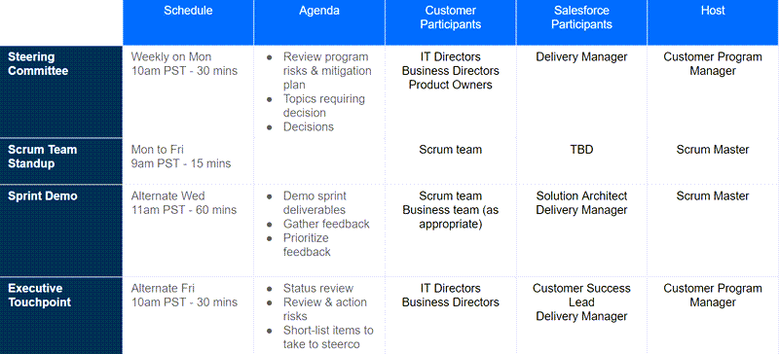

As well as formal meetings, use communication channels that are good for sharing information on an ad-hoc basis. For example, a dedicated company intranet page is useful for sharing project wins with the entire company, and a project Slack Channel is helpful for day-to-day queries, quick impromptu meetings and knowledge sharing in the project team and between key stakeholders.

Consider the Impacts of Your ESM Design  
You need to make some key decisions early in your implementation planning, which will have a big impact on the time and resources required for the implementation. The decisions affect the way your sales team works with the final solutions. Here are some examples.

[**CUSTOMER ACCOUNTS**](https://api.appinium.com/player/scorm12/content/ce6bcfd4-dbf4-47f3-8aef-04c8aec39cbf/00D1N000002LpRpUAK/c536aa51-d17f-a59e-bab5-aa59b5026c32/2a15f339-0609-4b57-9991-7de7d0b07272/scormcontent/index.html)

Here are some ESM-specific questions to ask about your company's customer accounts and the potential impacts these will have on your implementation.

| **Question** | **Impact** |
| --- | --- |
| Are you configuring by subscriber, location or both? | This will impact how you set up your Accounts, including billing and service accounts. |
| What information do you store about your customers? How does this map to the ESM customer model? | You may need to add  fields to the ESM data model and perform subsequent configuration work to ensure the custom fields are added to the Carts and available to the pricing and rules engines. |
| Where is this information stored? How is this recorded and by whom? | This will impact data mastery design and may lead to a requirement for further customization, for example using APIs to extract customer information from an external system to be used by ESM. Consideration of end users will likely have an impact on UX design and development. |
| When do you add customer information such as locations during the quotation and ordering process? | This will impact validation and pricing processes. For example configuration tied to pricing hooks may be necessary to ensure any changes are reflected in the Cart's prices. |

[**PRODUCTS**](https://api.appinium.com/player/scorm12/content/ce6bcfd4-dbf4-47f3-8aef-04c8aec39cbf/00D1N000002LpRpUAK/c536aa51-d17f-a59e-bab5-aa59b5026c32/2a15f339-0609-4b57-9991-7de7d0b07272/scormcontent/index.html)

Here are some ESM-specific questions about your company's products and pricing and validation processes, and the potential impacts on your implementation project.

| **Questions** | **Impacts** |
| --- | --- |
| What information do you store about your products and how does this differ from the out-of-the-box ESM product models? | Additional work will be required to configure and extend the data model to include any variations. |
| Does any product information come from external systems such as serviceability and number reservation systems? | This will require data model extension and additional integration work. It may also impact performance for the end user, which you should consider. |
| Are there any attributes that affect pricing? When/where/how are these set? | This will involve additional rules and pricing configuration. Consider the potential complexity and size of pricing matrices with multiple attributes. Very large matrices with frequently changing prices require considerable time for maintenance. |
| When should validation and pricing occur? | Ideally, this should be automatic, every time something is added or changed. However, if you frequently amend locations and configurations in very large quotes, this can impact performance. In this case, you may prefer a button click to trigger validation and pricing. |
| Considering the volumes of data involved and the complexity of the processes, should we be aware of any SLAs? | This could have a huge impact on the design, particularly if validation or pricing relies on information called through APIs from an external system. |

**Getting Started**  
No doubt you've already been thinking about the new processes and information you want that are missing from ESM, as well as what’s available in ESM that you don’t need. Now is a good time to stop, take a break, and start doing a bit of detective work.

Want to save time and effort? First, check if the capabilities you need are already available in ESM. If not, maybe ESM has out-of-the-box features you can tweak to fit your requirements. The long and short? Don’t waste time building something that already exists.

Customization Support  
Salesforce Industries Success Community is a great place to start when considering customizations to help ensure you are not reinventing the wheel in your project. The Community includes support groups, training materials, documentation, and a Process Library that provides data models, configured examples, and information sheets for download. Community resources help you ensure you’re following best practices in your configuration work.

Investigate your required processes and data and check them against the processes and data in ESM. Remember, some fields may already be present in the data model, but not visible on the out-of-the-box user interfaces. You can easily view objects and fields at any time using the Object Manager, which is available from the Salesforce Setup menu of your org. Here's an example of the fields list for an Account object in a recent ESM implementation, shown using the Object Manager.

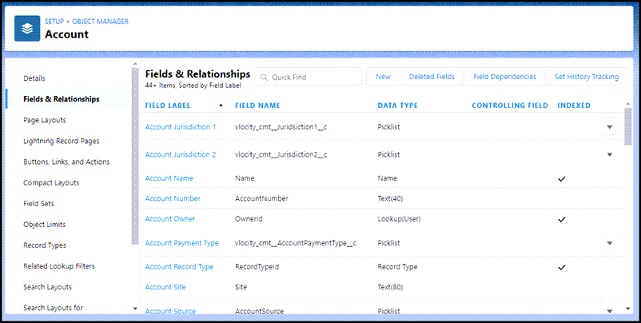

Out-of-the-Box or Customization  
Ok, so we get you’ll find some things you want to change in ESM. To get you started, here are some examples of the types of configurations you may require and what’s available out of the box:

* What information should be maintained in your Account records? Refer to the data mastery section of this course and ask your Salesforce implementation team if you need guidance. A common configuration requirement is when further information is required for Quote Members, such as additional address fields for locations. This may impact your Service Account data. Extending your quote member information may result in required changes to the out-of-the-box LWCs for your Cart and OmniScript changes to the out-of-the-box guided processes.
* The quote-and-order process often requires some customization on how quotes are converted into orders for consumption by the order-management system. Standard ESM functionality is to convert quotes directly to orders through a button click. However, the underlying data structures and processes are pre-built so you can add extra steps. For example, after the sales person submits their quote to order, you can have a second team step in to complete order details. This can support orchestration and fulfilment to provide additional technical information, for example, about the customer site. You may also decide you would rather not group your orders into parent orders and sub-orders. In this instance, you don’t have to use the out-of-the-box parent order records.

Here are some other examples of configurations you may want to consider in relation to what is available out of the box.

The User Experience  
Consider how your end users enter and check information then assess how you need to adapt the existing ESM UX to suit. ESM's interfaces are built using Lightning Web Components (LWCs). You can modify and extend the user interface, including adding or amending buttons, actions, and fields. To do this, clone and modify the relevant LWCs and incorporate Integration Procedures and DataRaptors to present the right data to your users at the right time. For examples, read the ESM documentation in Salesforce Industries Success Community.

What’s the best way to guide users through tasks they need to complete on a regular basis? Use Salesforce Industries OmniStudio to build guided flows using OmniScripts. Choose from these ESM-specific guided flows:

* b2bExpress/CreateQuote, which guides the user through creating quotes for enterprise customers; and
* b2bExpressCLM/generateProposalDocument, which guides the user through creating and generating a proposal document for the customer.

You can amend these flows to suit your own requirements using OmniScripts, which you can also use to create new guided flows.

The Products  
ESM currently provides three fully-fledged product offers out of the box: Business Internet, Business Mobile, and Business VPN. You learn about these in the ESM Data and Integration section of this course.

You can configure the out-of-the-box offers or extend them as you like. You can also create new offers. This is a complex process in which you need to consider object types, fields, attributes and picklists, offer structures, products, pricing, rules and associated orchestration plans.

Find more offer models to support you in the development process in the Process Library in the Support Community. You can also learn how to model and build offers using best practices through the Industries CPQ and Industries Order Management courses, which are available as instructor-led courses through Trailhead Academy, or as eLearning.

The Company Ecosystem  
Of course, ESM isn't the only application you have in your company - so think about how you can improve other business processes during your digital transformation journey. Think about the jobs to be done, who needs to do them, and when?

The nature and order of tasks and who performs them determines when applications trigger your business processes. You need to understand which application should be the data master for particular information. This knowledge  informs your integration requirements, and integrations are often complex and time-consuming. The ESM Data and Integration section of this course discusses integrations currently available out of the box. More are added periodically, so it is worth checking the release roadmap before starting any work to develop your own integrations.

Before You Start  
Choosing the right members for your implementation team is vital for the success of your digital transformation project. To help you decide, this lesson outlines some key roles and the skills and characteristics they need to excel. You also look at the wider impacts of the implementation on your employees. This helps you decide who to involve in the project and when. Consider these points when choosing your team:

* Highly skilled and well-trained small teams are key to successful deployments. Large teams who aren’t up to date with the latest versions of your applications and the tools and technologies relevant to the implementation put the project at risk. Ensure that all team members have the  required knowledge and skills before the project starts, because they may not have time to upskill once the project is underway.
* The end-user experience must always be first and foremost in everyone's mind. Therefore, ensure your UX designers are involved right from the start. Define the first MVP to include guided flows for the most common jobs to be done.
* Guess you would expect us to say this, but don't forget the training! Successful projects are those that plan for and invest in frequent training. Also make clear plans for CI/CD (Continuous Integration, Continuous Delivery), DevOps (Development Operations), testing, and release management.

The Salesforce Team:  Six Critical Roles  
Your ESM implementation team should have six key Salesforce roles that align with your existing digital transformation project teams, such as:

* Business transformation team
* Solution integration team
* Testing and QA team
* DevOps team
* Digital studio/agency team
* Any other Salesforce application implementation teams.

Your Company's Team: Who Will Support Your Success?  
Many people from your company should be involved at different stages of your digital transformation, with different levels of involvement. This varies from company to company, and from one implementation to the next. Here are some examples of the types of roles you can expect to participate, what they might contribute, and when they might be involved.



**IT Directors, Business Directors and Product Owners**  
These employees may be heavily involved in the initial decision to implement ESM and clearly understand the benefits and goals of the project. They’re informed of progress throughout the project and tend to meet as a group with the delivery manager at least once a week. At this time, they make decisions, review program risks, and discuss mitigation plans.

IT directors and business directors may meet every two weeks with the delivery manager, customer success lead, and customer program manager to review project status, action any risks, and short-list items for the main weekly meeting.

**Business Team**  
The business team is substantially involved in the initial discovery and design stages of the project. For example, system end users, such as service agents and sales executives, may be invited to demonstrate how they use their existing systems and share any obstacles in their day-to-day work. End users may also help design the new system and suggest improvements.

Once the development stage is underway, the business team stays up to date with progress through formal channels, such as a dedicated Slack channel. They may also attend sprint demonstrations during development and testing. These sprint demos, which the scrum team also attend, show the solution architect and delivery manager the in-progress solution so they can review and comment. Any feedback from the business team is collated, prioritized, and incorporated into the next sprint if required.

Some members of the business team may also be involved in the scrum team as part of the implementation. In this case, the business team works hand-in-hand with implementation teams from design to deployment. During the deployment stage, the business team takes  training to use the new ESM solution. At this point, encourage them to give feedback on their experience using  a standard feedback channel. This helps to facilitate ongoing improvement.

**Operations Team**  
Your operations team are the people who support the applications and systems that help your business team get their work done. Depending on the structure of your company, this may include system analysts, solution architects, solution integrators and security specialists.



Like the business team, the operations team is heavily involved in the design and definition of the ESM implementation, usually in the first month of the project For example, they may advise on legacy systems, DevOps process alignment, and applicable process and style standards in the company.

The operations team may also join the implementation scrum team to be more hands-on with the design, development, testing, and deployment of ESM. This can be a considerable time commitment and means the operations team works closely each day with the Salesforce ESM implementation team.

During the testing and deployment phases, some members of the operations team are likely to be heavily involved again in the implementation: some in an advisory role and others from a practical perspective. Be sure to provide training to ensure any handover runs smoothly.

**ESM and Communications 360**

ESM extends the Communications 360 data model to include information that large quotes and orders and complex B2B customers require. These data model extensions will impact your configuration and customization activities, so let's take some time now to make sure you can identify them.

**Accounts**

In the Account object, ESM uses three record types: the Business Account, Billing Account and Service Account.

* The Business Account represents the customer as a legal entity.
* When you create an enterprise quote, it's directly related to a Business Account record for your customer.
* You can then upload a list of subscribers or locations referenced in the quote.  These are Quote Members and are directly related to the Service Account records associated with the Business Account.

If you don't have quote groups or quote members for your quote, the Business Account, Billing Account and Service Account are all generally the same

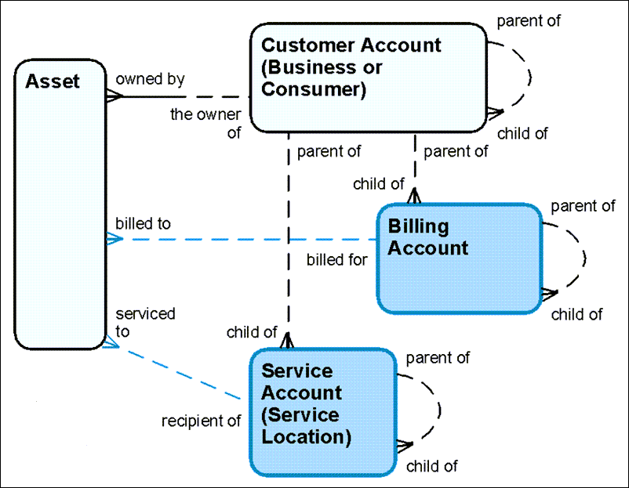

**Quotes and the Working Cart**

Enterprise quotes often have many line items with complex configuration. ESM extends the Industries CPQ data model to help aggregate and sort this data and process it effectively. Consider this typical quote scenario:

1. You add three separate offers to the Quote Cart. Each offer is a Root Quote Line Item, and any child products of the offers are Child Quote Line Items.  Remember these terms from the standard Industries CPQ data model?
2. One of the offers is specifically for the customer's London office, so you allocate it to a Quote Member, in this case the London office location. The location was specified during the initial quote process.
3. The second offer is for all the UK offices. You create a Quote Group called UK Office Group, which groups all the offices your customer has in the UK, and then allocates the second offer to that group. Configurations applied to this offer apply to the offer for every UK Office.

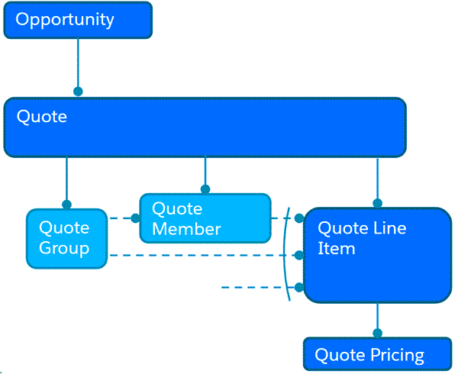

ESM improves the processing efficiency of your enterprise quotes by copying subsets of quote line items to a separate Working Cart, where they are updated, validated and priced using the Industries CPQ rules engines and price engines, before being moved back into the actual quote, as shown here. These subsets are generally Quote Groups.

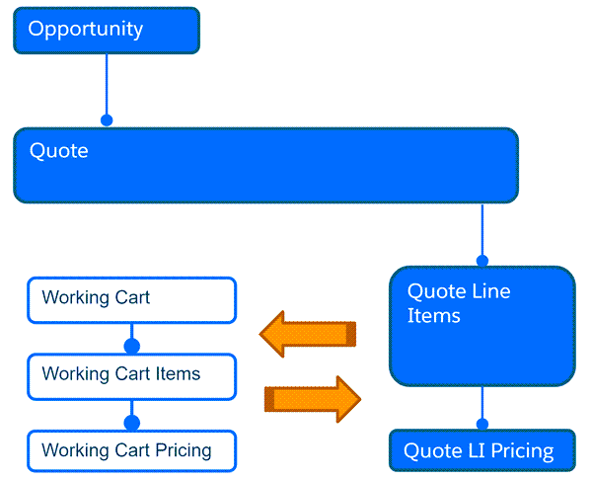

When you add a product to a group, you add a single, shared quote line item instance for all the members in the group. Any configuration you make on that quote line item applies to all members of the group. However, you may want to apply slightly different configuration or pricing for your product to some of your quote members. In this case, you can add the product to multiple group members directly. Select each member individually, and then add them to the product in bulk.

The objects and record types highlighted here are only some of the data collected.

Orders  
Once your customer is happy with their quote, you can convert it to an order. Two Order object record types support the large, complex orders created in B2B telecommunications:

* Parent Order: This acts as a container for grouping multiple sub-orders.
* Sub Order: This is an order for a single location, subscriber, or set of line items that are not associated with any quote member.

Parent orders group one or more sub orders. Taking the parent/sub-order approach gives you more efficient order processing, because the sub-orders are submitted and processed in batches rather than in one massive order. It also means that any changes required on any particular sub order don’t hold up the processing of other sub orders in the parent order.

After the quote is converted to an order, and before the orders and sub-orders are submitted to your order-management system, ESM evaluates the parent order and sub-orders. At this point, if your quote member isn’t already allocated a service account, ESM automatically creates one for you.

**Why Pre-Built Products?**

Product modelling is both an art and a science, and it takes a while to become really great at it. It's a time-consuming, iterative process, and if you get it wrong, there can be negative consequences. These include delays to market, performance delays, confusing shopping experiences for your customers, and as a worst case scenario, a lot of work to remodel and recreate products.

Scared yet? No need! Salesforce has made sure you start off on the right foot by giving  you pre-built models for common B2B telecommunications products. Use the models to help you make the right decisions when you first start modelling your own products. You can amend the models to suit your business requirements, to boot.

The models are for Business Internet, Business Mobile, and Business VPN. You also get order-management templates that correspond to each model, available out of the box. Use the templates to help you map offers to products and customer-facing services to support order orchestration.

[**BUSINESS INTERNET**](https://api.appinium.com/player/scorm12/content/9e2275ec-e8bf-4e48-a133-e8ccc98284da/00D1N000002LpRpUAK/6628e122-20dd-8e2b-2657-5848467c1439/d8d9405f-e9bf-4f41-8dea-74002862af1e/scormcontent/index.html)

The Business Internet model is a hierarchical product model with three types of plan: Business Internet Essential, Business Internet Enhanced and Business Internet Pro.

Each plan features:

* A fixed-access line to the customer's premises, which can be wired or wireless.
  + Hardware, including:
* Customer Premises Equipment (CPE)
  + Accessories, like access points, Wi-Fi extenders, and cables
  + Services, including:
* Installation services
  + Supplementary services, such as security solutions, static IP addresses, mailboxes, security licenses, and hosting
  + Business-specific features typically unavailable to consumers, such as public Wi-Fi for customers and office visitors, and wireless backup to provide limited access line protection

Click the image to zoom in. The model builds from an Internet S/M/L/XL Offer, which has attributes associated, including the contract term, download speed, and monthly data cap. There’s also a price set on the offer. Required and optional child offer specifications are associated, including public Wi-Fi, installation, and CPE.

Take a closer look at the CPE. You see it’s a mandatory part of the offer, because the  cardinality is 1.1.1. This means the minimum number the customer can order is 1, the maximum is 1, and the default value is 1. However, the customer may choose from many different types of CPE. These can be configured either automatically using an attribute and pricing matrix, or the sales agent or customer can configure the offers.

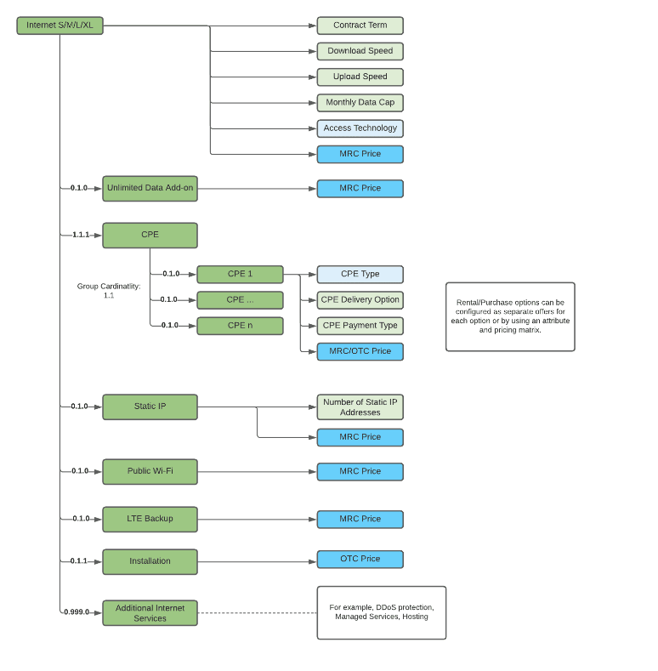

[**BUSINESS MOBILE**](https://api.appinium.com/player/scorm12/content/9e2275ec-e8bf-4e48-a133-e8ccc98284da/00D1N000002LpRpUAK/6628e122-20dd-8e2b-2657-5848467c1439/d8d9405f-e9bf-4f41-8dea-74002862af1e/scormcontent/index.html)

The Business Mobile product model includes plans for four levels of offer: Business Mobile Essential, Business Mobile Enhanced, Business Mobile Pro, and Business Mobile Pro+. Each plan includes similar services, but with different configuration for voice, data, SMS, and other services. Click the image to take a closer look.

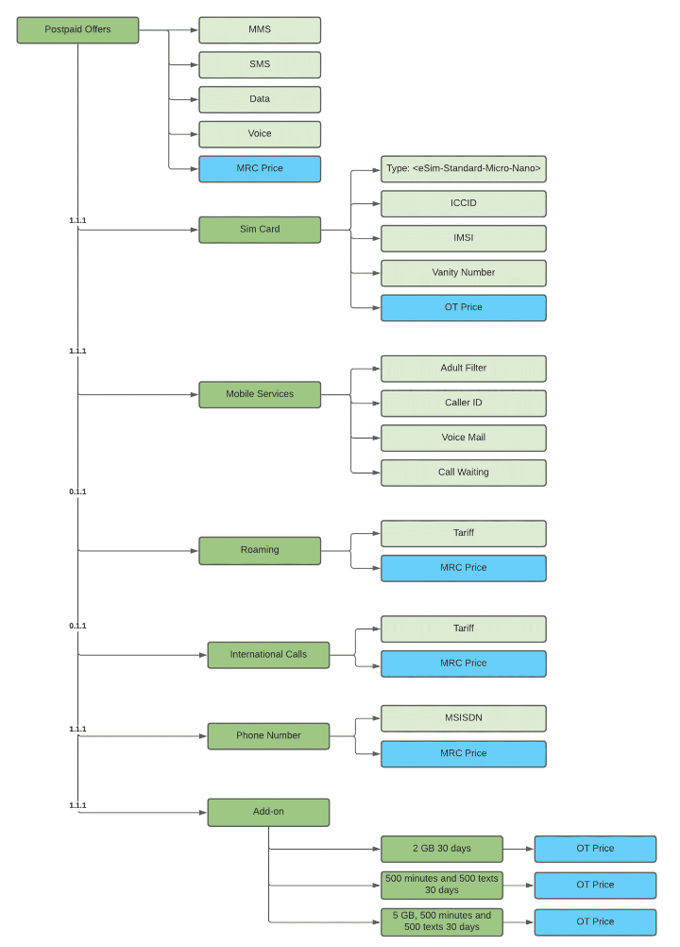

[**BUSINESS VPN**](https://api.appinium.com/player/scorm12/content/9e2275ec-e8bf-4e48-a133-e8ccc98284da/00D1N000002LpRpUAK/6628e122-20dd-8e2b-2657-5848467c1439/d8d9405f-e9bf-4f41-8dea-74002862af1e/scormcontent/index.html)

The Business VPN model is designed to support different WAN use cases, like internet breakout to local access points, site connections, connections to a data center, and different combinations of WAN, EVC, UNI and CPE.

In this model:

* **WAN site** is a physical location where a site access line terminates and CPE is installed. To enable specific network configurations for different sites, a WAN site is considered a separate product element. The WAN solution assumes that a site access line is present on the customer premises.
* **EVC** is an association between two or more user network interfaces. This can be an EVC and a UNI, such as an E-LINE EVC with two endpoints or an E-LAN with many endpoints. For VLAN-based WANs, like an EVP LAN, multiple endpoints can reside in a single UNI. To facilitate scalability, this model treats EVC endpoints as part of a WAN site, although they are typically considered part of an EVC.
* **UNI**: One CPE item can host multiple UNIs, for example when terminating multiple EVCs or enabling protection schema.
* **CPE**can vary to support:
* Reuse of existing CPE from another network solution previously deployed at the site
  + Multiple CPEs installed at a site to terminate different EVCs
  + Where the UNI is on a provider edge (PE) router

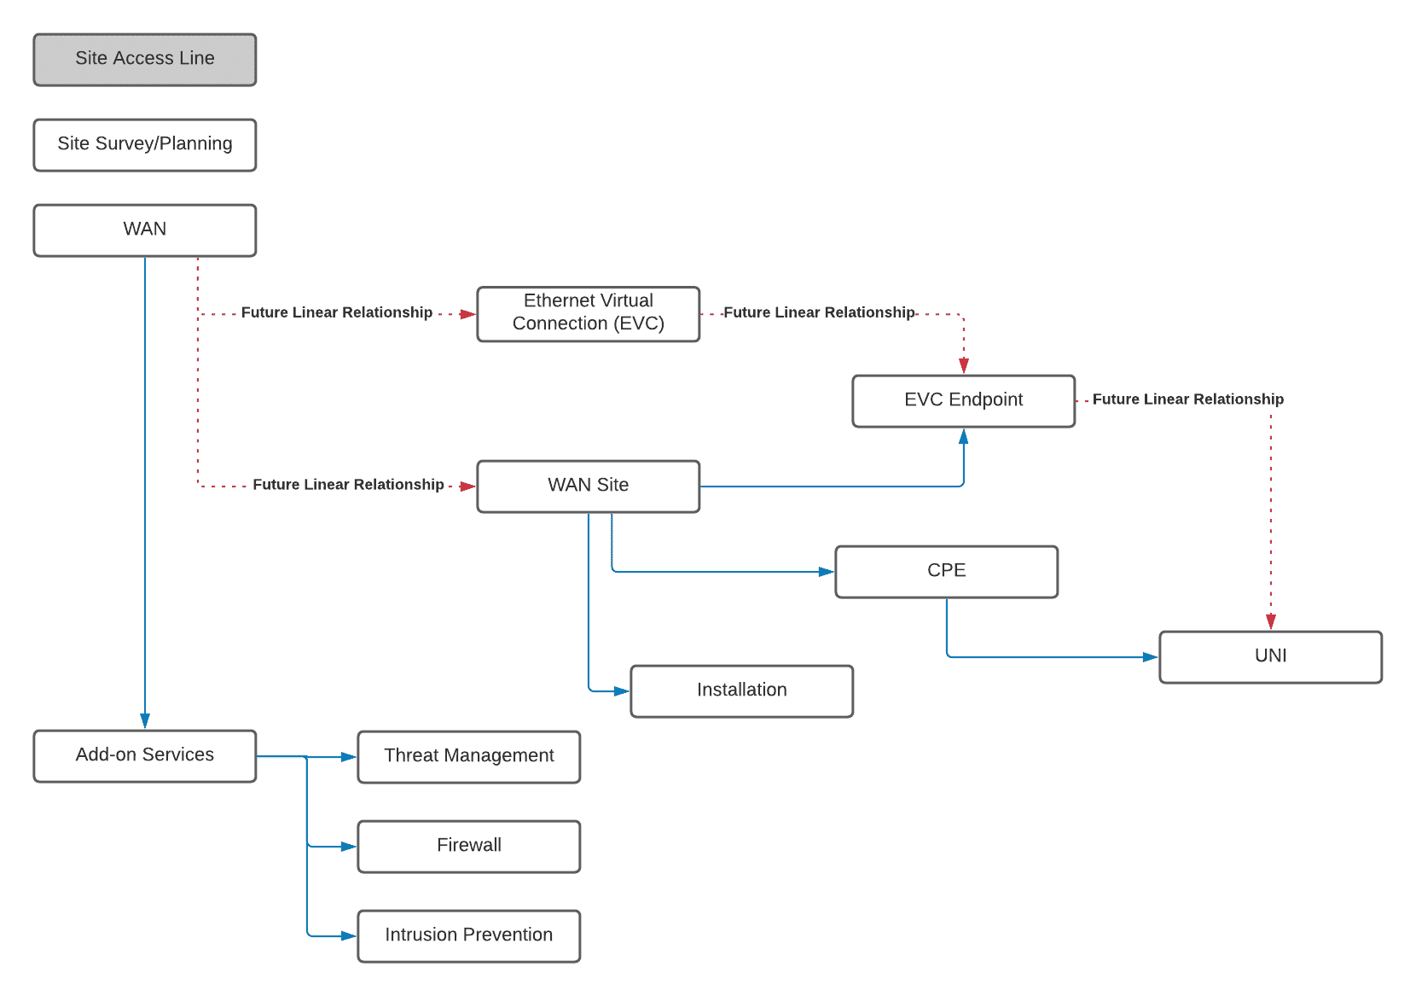

**Oh Great, More Acronyms!**

As you might have already noticed, the communications industry has a bewildering array of acronyms for you to grasp. To help you out, here are some you'll come across when discussing the ESM models.

|  |  |
| --- | --- |
| **Acronyms Used in the Models** | |
| CPE | Customer premises equipment: a termination device located on-premise, such as a modem, router, or access point. |
| EVC | Ethernet virtual connection: an association of at least two UNIs that identifies paths in the service provider network |
| EVP-LAN | Ethernet Virtual Private LAN: connects UNIs, usually on a metro network, and is used when a customer network covers multiple sites that share data |
| ICCID | Integrated Circuit Card Identifier: a unique 18 - 22 digit code that specifies the industry, region, network, and device of a SIM card |
| IMSI | International Mobile Subscriber Identifier: a unique code of up to 15 digits assigned to each mobile network connection, which references the country code, network operator code, and mobile device number |
| LAN | Local Area Network: a network confined to a small area, such as a building |
| MMS | Multimedia Messaging Service |
| MRC | Monthly recurring charge |
| OTC | One-time charge |
| SMS | Short Messaging Service: text messages up to 160 characters |
| UNI | User-network interface: a physical network interface port where equipment such as a customer LAN is connected |
| VLAN | Virtual local area network:  connected devices grouped and treated as a LAN but not necessarily in the same geographical area |
| VPN | Virtual private network: creates a secure, encrypted connection from a public internet connection |
| WAN | Wide area network: generally a group of LANs that communicate with each other over a wide geographical area. |

What is Data Mastery?  
Data mastery is the process of identifying one system or repository of data as the source of truth for that data. Any system that masters data should have controls in place to ensure data accuracy and consistency. The master system also needs good data governance to ensure that the right people and processes have the right access to the right data at the right time. Only then can you trust the system to share clean, accurate master records with its subscribers through integration. If data ever becomes discrepant or out of sync, you can usually rely on the records in the master system to be correct.

For your ESM implementation, you need to decide what systems should be the masters, and what systems should be subscribers. To get started, consider these basic guidelines.

Advantages to mastering data in Communications Cloud:

* Access to the data is rapid and low cost because it's stored on the Salesforce platform.
* Calls to off-platform applications for data aren't needed.
* The overall advantage is availability.

Advantages to mastering data in legacy systems or third-party systems:

* Data held off-platform is always the latest version.
* Checking the master data source for updates isn't required.
* The overall advantage is data reliability.

**Data Mastery Examples**

* Which System has the Data Master?

This depends on the nature of your business and third-party systems.  Let's see some common examples of data mastery patterns.

* Business Account Data

Master Business Account data in Communications Cloud, because this data is relevant to the overall 360 view of a customer.

* Contact Data

You should also master Contact data in Communications Cloud. Contact data is key customer relationship management (CRM) data for the individuals linked to an account. You can send the data to back-end systems, but it’s not essential to the operation of billing systems.

* Interaction Data

All records of interaction between customers and your company should be mastered in Communications Cloud for the same reason as contact data: CRM-related data should be mastered in the same place. Also, this data isn’t important in billing systems.

* Billing Data

All billing-related data should be mastered in the billing system. This includes billing account information, bill details, payments, and adjustments. You can store the most frequently accessed billing information in Communications Cloud as a copy to support performance and search functionality.

* Premises and Service Access Data

Data mastery for premises information depends on the nature of the product and the level of regulation of the market. For example, if you’re selling telecommunications services in a regulated market, the area you may service is predefined. Often, specific billing rules apply, so it’s recommended that you keep master data  for premises in the billing system. However, the data should be replicated to ESM for move-in and move-out processes. In a deregulated market, it’s more likely you’ll master your premises data in Communications Cloud. Premise and access point data is also sent to the billing system, because this data forms the basis of billing for a customer.

Integration Basics  
Although Salesforce Customer 360 provides a solution for your marketing, sales, commerce, service, and IT departments, the ESM team knows there’s more to the picture. Most likely, you have systems you need to integrate with ESM to support the quote and order process. These systems may include back-office systems, such as billing, asset, field services, and outage management.

The good news? ESM gives you out-of-the-box integrations and processes, as well as tools to build your own custom integrations

**Integration Tools**

ESM provides an out-of-the-box solution for large quotes and orders, but think of this as a starting point for your sales teams and customize it to suit your business. Use ESM tools to create faster and less costly integration and configuration. Even better, add customizations and integrations incrementally as and when your ESM solution needs them.

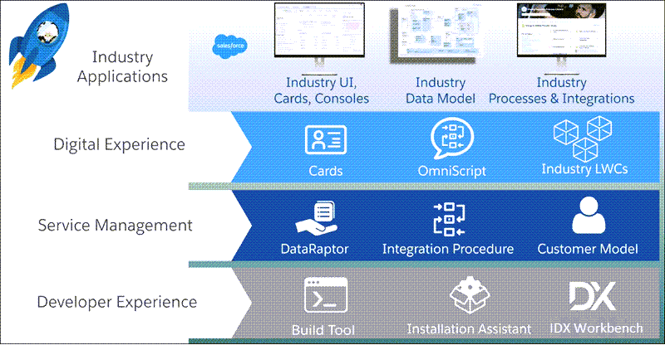

**Telecommunications Industry-Specific Applications:**Less time is required to configure the user interface and data model to suit your business, because components are pre-built with your industry in mind.

**Digital Experience:** Tools such as OmniScripts and OmniStudio Actions take advantage of a declarative approach. Combined with Lightning Web Components, the tools give you faster user experience configuration and connected process development. One of the great features of the tools is that they allow customers to skip from one channel to another without losing their input. For example, they can start an order on the self-service web site, and then call the contact center to finish the order, with all the information they provided earlier accessible in all channels, at every point.

**Service Management**: Tools such as DataRaptors, Integration Procedures, and Pre-Built Customer Models facilitate product and service management. They provide a declarative (clicks not code) integration interface, enabling faster and more agile ability to combine data from within and outside of Salesforce into integrated experiences.

**Developer Experience:**The Build Tool, Installation Assistant, and IDX Workbench enable faster deployment in multi-org, multi-configurator/developer environments.

**Out-of-the-Box Process Flows**

Before you create customizations, ensure that  your requirements aren’t already met by out-of-the-box ESM capabilities. You should also check the ESM roadmap for upcoming features that may support your business needs. Here are some existing process flows and integrations already included out of the box as part of the ESM managed package.

1. **Customer-Related Processes**

These include creating and amending accounts, importing and amending subscribers and locations, changing plans, and move in/move out guided processes.

1. **Pricing**

An additional pricing step is added to the pricing plan steps in ESM to retrieve the best price for the offer in a related frame agreement. You can learn more about this in the Contract Lifecycle Management training course. The ESM Developer Course explains how to implement this pricing.

1. **Google Maps**

ESM can use Google Maps APIs to find locations on a map. To enable this functionality, generate the required Google Maps API key in the Google Maps platform, and then add this key to your org. The key is used to validate Google Maps API calls.

1. **Tableau Integration**

ESM integrates out of the box with the analytics application, Tableau, to provide insights on your sales data and help your sales team prioritize their workloads.